UNITED STATES
SECURITIES AND EXCHANGE COMMISSION
Washington, D.C. 20549
FORM 8-K
CURRENT REPORT
PURSUANT TO SECTION 13 OR 15(d) OF THE SECURITIES EXCHANGE ACT OF 1934
Date of Report (Date of earliest event reported): August 6, 2026
KINGSTONE COMPANIES, INC.
(Exact name of registrant as specified in its charter)
Delaware |  |  |  |  |  | 000-01665 |  |  |  |  |  | 36-2476480
(State or other jurisdiction  of incorporation) |  |  |  |  |  | (Commission  File Number) |  |  |  |  |  | (IRS Employer  Identification No.)
120 Wood Road  Kingston, New York |  |  |  |  |  | 12401
(Address of principal executive offices) |  |  |  |  |  | (Zip code)
Registrant's telephone number, including area code (845) 802-7900
Securities registered pursuant to Section 12(b) of the Securities Exchange Act of 1934:
Title of each class |  |  | Trading Symbol(s) |  |  | Name of each exchange on which registered
Common Stock, $0.01 par value per share |  |  | KINS |  |  | NASDAQ
Check the appropriate box below if the Form 8-K filing is intended to simultaneously satisfy the filing obligation of the registrant under any of the following provisions (see General Instruction A.2. below):
☐ Written communications pursuant to Rule 425 under the Securities Act (17 CFR 230.425)
☐ Soliciting material pursuant to Rule 14a-12 under the Exchange Act (17 CFR 240.14a-12)
☐ Pre-commencement communications pursuant to Rule 14d-2(b) under the Exchange Act (17 CFR 240.14d-2(b))
☐ Pre-commencement communications pursuant to Rule 13e-4(c) under the Exchange Act (17 CFR 240.13e-4(c))
Indicate by check mark whether the registrant is an emerging growth company as defined in Rule 405 of the Securities Act of 1933 (§230.405 of this chapter) or Rule 12b-2 of the Securities Exchange Act of 1934 (§240.12b-2 of this chapter):
Emerging growth company ☐
If an emerging growth company, indicate by check mark if the registrant has elected not to use the extended transition period for complying with any new or revised financial accounting standards provided pursuant to Section 13(a) of the Exchange Act. o

Item 2.02 Results of Operations and Financial Condition.
On August 6, 2026, Kingstone Companies, Inc. (the “Company”) issued a press release announcing its financial results for the quarter ended June 30, 2026 (the “Press Release”). The Press Release also announced that the Company will hold a conference call for analysts and investors on August 7, 2026 at 8:30 A.M. ET. (the “Conference Call”), as previously announced on July 16, 2026, and that the Company has prepared an investor presentation (the “Presentation Materials”) that can be accessed through the News & Events/Presentations section of the Company website (www.kingstonecompanies.com). Copies of the Press Release and the Presentation Materials are furnished as Exhibits 99.1 and 99.2, respectively, hereto.

The Company intends to use the Presentation Materials in connection with the Conference Call and may use the Presentation Materials from time to time, possibly with modification, in other presentations to current and potential investors, lenders, creditors, insurers, vendors, customers, employees and others with an interest in the Company and its business.

The information contained in the Press Release and the Presentation Materials is summary information that should be considered in the context of the Company’s filings with the Securities and Exchange Commission and other public announcements that the Company may make by press release or otherwise from time to time. The Presentation Materials speak as of the date of this Current Report on Form 8-K. While the Company may elect to update the Presentation Materials in the future or reflect events and circumstances occurring or existing after the date of this Current Report on Form 8-K, the Company specifically disclaims any obligation to do so.

The information furnished with this Item 2.02, including Exhibits 99.1 and 99.2, shall not be deemed “filed” for purposes of Section 18 of the Securities Exchange Act of 1934, as amended (the “Exchange Act”), or otherwise subject to the liabilities of that section, nor shall it be deemed incorporated by reference into any other filing under the Securities Act of 1933, as amended (the “Securities Act”), or the Exchange Act, except as expressly set forth by specific reference in such a filing

Item 7.01 Regulation FD Disclosure.
See Item 2.02 above.
The information in the Press Release and the Presentation Materials is being furnished, not filed, pursuant to this Item 7.01. Accordingly, the information in the Press Release and the Presentation Materials will not be incorporated by reference into any registration statement filed by the Company under the Securities Act unless specifically identified therein as being incorporated therein by reference. The furnishing of the information in this Current Report on Form 8-K with respect to the Press Release and the Presentation Materials is not intended to, and does not, constitute a determination or admission by the Company that the information in this Report with respect to the Press Release and the Presentation Materials is material or complete, or that investors should consider this information before making an investment decision with respect to any security of the Company.

Item 9.01 Financial Statements and Exhibits.
(d) |  |  | Exhibits:
 |  |  | 99.1 |  |  | Press release, dated August 6, 2026, issued by Kingstone Companies, Inc.
 |  |  | 99.2 |  |  | Presentation Materials
 |  |  | 104 |  |  | Cover Page Interactive Data File (embedded within the inline XBRL document).

SIGNATURES
Pursuant to the requirements of the Securities Exchange Act of 1934, the registrant has duly caused this report to be signed on its behalf by the undersigned hereunto duly authorized.
 |  |  | KINGSTONE COMPANIES, INC.
Dated: August 6, 2026 |  |  | By: |  |  | /s/ Randy Patten
 |  |  |  |  |  | Randy Patten
 |  |  |  |  |  | CFO



Kingstone Reports Second Quarter 2026 Results

Most Profitable Quarter in Company History
Q2 Diluted Net Income Per Share of $1.05 | Q2 Annualized Return on Equity of 50.8%
Net Premiums Earned Growth of 31% for Q2 | Direct Premiums Written Growth1 of 19% for Q2
Q2 GAAP Net Combined Ratio of 70.2%
Company Reaffirms 2026 Full Year Guidance

Management to Host Conference Call Tomorrow at 8:30 a.m. Eastern Time

Kingston, NY — August 6, 2026 – Kingstone Companies, Inc. (Nasdaq: KINS) (“Kingstone” or the “Company”), a regional property and casualty insurance holding company, today announced its financial results for the second quarter ended June 30, 2026. The Company has also provided an investor presentation that can be accessed through the News & Events/Presentations section of the Company website at www.kingstonecompanies.com.

Key Financial and Operational Highlights
 |  |  | Quarters Ended |  |  |  |  |  |  |  |  | Six Months Ended
 |  |  | June 30, |  |  |  |  |  |  |  |  | June 30,
($ in thousands, except per share data) |  |  | 2026 |  |  | 2025 |  |  | Change |  |  | 2026 |  |  | 2025 |  |  | Change
Net premiums earned |  |  | $ | 60,467 |  | $ | 46,215 |  | 30.8% |  |  | $ | 116,336 |  | $ | 89,738 |  | 29.6%
Direct premiums written1 |  |  | $ | 72,494 |  | $ | 61,062 |  | 18.7% |  |  | $ | 142,097 |  | $ | 119,237 |  | 19.2%
Net combined ratio |  |  | 70.2% |  |  | 71.5% |  |  | (1.3)pts |  |  | 90.2% |  |  | 82.3% |  |  | 7.9pts
Catastrophe loss ratio1 |  |  | (0.8)% |  |  | 0.6% |  |  | (1.4)pts |  |  | 12.0% |  |  | 1.2% |  |  | 10.8pts
Underlying combined ratio1 |  |  | 73.7% |  |  | 71.4% |  |  | 2.3pts |  |  | 80.7% |  |  | 82.0% |  |  | (1.3)pts
Net income |  |  | $ | 15,470 |  | $ | 11,252 |  | 37.5% |  |  | $ | 9,662 |  | $ | 15,135 |  | (36.2)%
Net income per share - diluted |  |  | $ | 1.05 |  | $ | 0.78 |  | 34.6% |  |  | $ | 0.66 |  | $ | 1.07 |  | (38.3)%
Operating net income per share - diluted1 |  |  | $ | 1.04 |  | $ | 0.75 |  | 38.7% |  |  | $ | 0.70 |  | $ | 0.94 |  | (25.5)%
Return on equity - annualized |  |  | 50.8% |  |  | 50.8% |  |  | —pts |  |  | 15.3% |  |  | 37.4% |  |  | (22.1)pts
1 Refer to section entitled "Definitions and Non-GAAP Measures" included in this press release for definitions and reconciliations of non-GAAP financial measures to the most comparable GAAP measures.

Management Commentary
Meryl Golden, President and Chief Executive Officer of Kingstone, stated, "I am very pleased to report the most profitable quarter in Kingstone's history. Net income was a record $15.5 million, diluted earnings per share rose 35% to $1.05, and our GAAP net combined ratio improved to 70.2%, resulting in an annualized return on equity of 50.8%. Diluted book value per share increased 35% year-over-year to $8.69.

Direct premiums written1 grew 18.7%, led by continued strength in New York personal lines. Net premiums earned rose 31% as premiums from our reduced quota share continue to earn in. Our 39.6% net loss ratio included favorable prior-year reserve development and a negative catastrophe loss ratio, as favorable development on our first-quarter catastrophe estimate exceeded second-quarter catastrophe losses. Our underwriting expense ratio improved to 30.6%, reflecting the operating leverage of our scalable platform. Net investment income increased 49% on a growing investment portfolio and higher yields.

Our strong capital position supports profitable growth and disciplined capital returns. We completed our catastrophe reinsurance placement that increased total coverage to $500 million, added wildfire protection, maintained low first-event retentions and reduced the risk-adjusted cost of our core catastrophe excess of loss coverage by more than 15%. We also announced a share repurchase authorization during the quarter and subsequently increased our quarterly dividend by 20% to $0.06 per share, one year after reinstating it. We remain confident in our trajectory and committed to delivering long-term value to our shareholders."
1

Fiscal Year 2026 Outlook
(see “Disclaimer and Forward-Looking Statements” below)

The Company is reaffirming its growth, underwriting and profitability outlook for fiscal year 2026, which was originally issued on March 5, 2026 and affirmed on May 7, 2026. The guidance below reflects management’s expectations based on information available as of August 6, 2026 and is subject to the risks and uncertainties described in “Disclaimer and Forward-Looking Statements” below.

Guidance Metrics |  |  | 2026 Estimate
Direct premiums written1,4 growth |  |  | 16% to 20%
Net combined ratio |  |  | 81% to 86%
Underlying combined ratio1,2 (excluding catastrophe losses and prior-year reserve development) |  |  | 74% to 76%
Prior-year reserve development |  |  | —%
Catastrophe loss ratio1,3 |  |  | 7% to 10%
Net income per share – diluted |  |  | $2.20 to $2.90
Return on equity |  |  | 24% to 30%
¹Refer to “Definitions and Non-GAAP Measures” for definitions and reconciliations of non-GAAP financial measures to the most comparable GAAP measures.
²The underlying combined ratio is a non-GAAP measure. It is computed as the sum of the underlying loss ratio (which is a non-GAAP measure) and the net underwriting expense ratio. The underlying loss ratio excludes catastrophe losses and prior-year reserve development from the GAAP net loss ratio. The most directly comparable GAAP measure is the net combined ratio. Refer to the section entitled “Definitions and Non-GAAP Measures” included in this press release for definitions and reconciliations of non-GAAP financial measures. A reconciliation of the 2026 estimate of underlying combined ratio to the GAAP net combined ratio is not provided because the Company is unable to predict catastrophe losses and prior-year reserve development with reasonable certainty without unreasonable efforts. These items could materially impact the GAAP measure of net combined ratio.
³ The catastrophe loss ratio estimate for 2026 of 7% to 10% is at or above the Company’s six-year historical average of 7.1% (2019–2024) and gives effect to the elevated winter storm activity experienced in first quarter of 2026. Catastrophe losses are reported net of reinsurance recoveries and include loss adjustment expenses. The Company defines catastrophe events consistent with PCS industry designations.
4Guidance for the most comparable GAAP measure, net premiums earned, is not provided because net premiums earned is an output of multiple variables including direct written premium growth, quota share cession rates, and premium earning patterns, several of which are not within the Company’s direct control; therefore the Company is unable to predict such variables with reasonable certainty without unreasonable efforts.

Key Modeling Assumptions
The following reflects certain key modeling assumptions with respect to the full year 2026 guidance:

Assumption |  |  | 2026E
Assumed effective tax rate |  |  | 21%
Weighted average diluted shares outstanding |  |  | 14.8 million

2
Consolidated Financial Results

Consolidated Financial Results |  |  | Quarters Ended |  |  |  |  |  |  |  |  | Six Months Ended
($ in thousands, except policy and per share data) |  |  | June 30, |  |  |  |  |  |  |  |  | June 30,
 |  |  | 2026 |  |  | 2025 |  |  | Change |  |  | 2026 |  |  | 2025 |  |  | Change
Net premiums earned |  |  | $ | 60,467 |  | $ | 46,215 |  | 30.8% |  |  | $ | 116,336 |  | $ | 89,738 |  | 29.6%
Direct premiums written1 |  |  | $ | 72,494 |  | $ | 61,062 |  | 18.7% |  |  | $ | 142,097 |  | $ | 119,237 |  | 19.2%
Policies in force, at the end of the period |  |  | 84,570 |  |  | 76,925 |  |  | 9.9% |  |  | 84,570 |  |  | 76,925 |  |  | 9.9%
Net investment income |  |  | $ | 3,429 |  | $ | 2,300 |  | 49.1% |  |  | $ | 6,766 |  | $ | 4,349 |  | 55.6%
Net gains (losses) on investments |  |  | $ | 240 |  | $ | 546 |  | (56.0)% |  |  | $ | (775) |  | $ | 408 |  | (290.0)%
Gain on sale of real estate |  |  | $ | — |  | $ | — |  | —% |  |  | $ | — |  | $ | 1,966 |  | (100.0)%
Net loss ratio |  |  | 39.6% |  |  | 38.8% |  |  | 0.8pts |  |  | 59.7% |  |  | 50.3% |  |  | 9.4pts
Net underwriting expense ratio |  |  | 30.6% |  |  | 32.7% |  |  | (2.1)pts |  |  | 30.5% |  |  | 32.0% |  |  | (1.5)pts
Net combined ratio |  |  | 70.2% |  |  | 71.5% |  |  | (1.3)pts |  |  | 90.2% |  |  | 82.3% |  |  | 7.9pts
Net loss ratio |  |  | 39.6% |  |  | 38.8% |  |  | 0.8pts |  |  | 59.7% |  |  | 50.3% |  |  | 9.4pts
Catastrophe loss ratio1 |  |  | (0.8)% |  |  | 0.6% |  |  | (1.4)pts |  |  | 12.0% |  |  | 1.2% |  |  | 10.8pts
Net loss ratio excluding the effect of catastrophes1 |  |  | 40.4% |  |  | 38.2% |  |  | 2.2pts |  |  | 47.7% |  |  | 49.1% |  |  | (1.4)pts
Effect of prior-year favorable reserve development |  |  | (2.7)% |  |  | (0.5)% |  |  | (2.2)pts |  |  | (2.5)% |  |  | (0.9)% |  |  | (1.6)pts
Underlying loss ratio1 |  |  | 43.1% |  |  | 38.7% |  |  | 4.4pts |  |  | 50.2% |  |  | 50.0% |  |  | 0.2pts
Net income |  |  | $ | 15,470 |  | $ | 11,252 |  | 37.5% |  |  | $ | 9,662 |  | $ | 15,135 |  | (36.2)%
Net income per share - basic |  |  | $ | 1.07 |  | $ | 0.81 |  | 32.1% |  |  | $ | 0.67 |  | $ | 1.10 |  | (39.1)%
Net income per share - diluted |  |  | $ | 1.05 |  | $ | 0.78 |  | 34.6% |  |  | $ | 0.66 |  | $ | 1.07 |  | (38.3)%
Return on equity - annualized |  |  | 50.8% |  |  | 50.8% |  |  | —pts |  |  | 15.3% |  |  | 37.4% |  |  | (22.1)pts
Adjusted EBITDA1 |  |  | $ | 20,738 |  | $ | 14,783 |  | 40.3% |  |  | $ | 15,791 |  | $ | 19,038 |  | (17.1)%
Other comprehensive (loss) income, net of tax |  |  | $ | (385) |  | $ | 1,022 |  | (137.7)% |  |  | $ | (2,441) |  | $ | 3,245 |  | (175.2)%
Operating net income1 |  |  | $ | 15,280 |  | $ | 10,821 |  | 41.2% |  |  | $ | 10,274 |  | $ | 13,259 |  | (22.5)%
Operating net income per share - basic1 |  |  | $ | 1.06 |  | $ | 0.78 |  | 35.9% |  |  | $ | 0.71 |  | $ | 0.97 |  | (26.8)%
Operating net income per share - diluted1 |  |  | $ | 1.04 |  | $ | 0.75 |  | 38.7% |  |  | $ | 0.70 |  | $ | 0.94 |  | (25.5)%
Operating return on equity1 |  |  | 12.5% |  |  | 12.2% |  |  | 0.3pts |  |  | 8.2% |  |  | 16.4% |  |  | (8.2)pts
Operating return on equity1 - annualized |  |  | 50.2% |  |  | 48.9% |  |  | 1.3pts |  |  | 16.3% |  |  | 32.8% |  |  | (16.5)pts
Book value per share, at the end of the period - diluted |  |  |  |  |  |  |  |  |  |  |  | $ | 8.69 |  | $ | 6.44 |  | 34.9%
Book value per share, at the end of the period - diluted excluding AOCI |  |  |  |  |  |  |  |  |  |  |  | $ | 9.27 |  | $ | 7.04 |  | 31.7%
1Refer to section entitled "Definitions and Non-GAAP Measures" included in this press release for definitions and reconciliations of non-GAAP financial measures to the most comparable GAAP measures.

3
Conference Call Details
Friday, August 7, 2026, at 8:30 a.m. Eastern Time

To participate please dial:

U.S. toll free 1-877-407-2991
International 1-201-389-0925

Participants are asked to dial-in approximately 10 minutes before the conference call is scheduled to begin. The conference call will also be available via live webcast on the Company’s website under the News & Events/Presentations section at www.kingstonecompanies.com. A replay will be available for 30 days.

About Kingstone Companies, Inc.
Kingstone is a regional property and casualty insurance holding company whose principal operating subsidiaries write business through retail and wholesale agents and brokers. Kingstone delivers tailored homeowners insurance solutions through its sophisticated product suite, Select, supported by a scalable and efficient operating platform that enables the Company to pursue significant market opportunities and strategic expansion. Kingstone was the 11th largest writer of homeowners insurance in New York in 2025 and also writes homeowners coverage in California on a non-admitted basis.

Investor Relations Contact:
Elevate IR
KINS@elevate-ir.com
720-330-2829

4
Disclaimer and Forward-Looking Statements
The guidance provided above is based on information available as of August 6, 2026 and management's review of the anticipated financial results for 2026. Such guidance remains subject to change based on management's ongoing review of the Company's 2026 results and is a forward-looking statement (see below). Kingstone assumes no obligation to update this guidance. The actual results may be materially different and are affected by the risk factors and uncertainties identified in this press release and in Kingstone's annual and quarterly filings with the Securities and Exchange Commission.

This press release may contain “forward-looking statements” within the meaning of the Private Securities Litigation Reform Act of 1995. All statements, other than statements of historical facts, may be forward-looking statements. These statements are based on management’s current expectations and are subject to uncertainty and changes in circumstances. These statements involve risks and uncertainties that could cause actual results to differ materially from those included in forward-looking statements due to a variety of factors. For more details on factors that could affect expectations, see Part I, Item 1A of our Annual Report on Form 10-K for the year ended December 31, 2025.

The risks and uncertainties include, without limitation, the following:

•the risk of significant losses from catastrophes and severe weather events;
•risks related to the lack of a financial strength rating from A.M. Best;
•risks related to limitations on the ability of our insurance subsidiary to pay dividends to us;
•adverse capital, credit and financial market conditions;
•risks related to volatility in net investment income;
•the unavailability of reinsurance at current levels and prices;
•the exposure to greater net insurance losses in the event of reduced reliance on reinsurance;
•the credit risk of our reinsurers;
•the inability to maintain the requisite amount of risk-based capital needed to grow our business;
•the effects of climate change on the frequency or severity of weather events and wildfires;
•risks related to the limited market area of our business;
•risks related to a concentration of business in a limited number of producers;
•legislative and regulatory changes, including changes in insurance laws and regulations and their application by our regulators;
•the effects of competition in our market areas;
•our reliance on certain key personnel;
•risks related to security breaches or other attacks involving our computer systems or those of our vendors;
•our reliance on information technology and information systems; and
•the uncertainty relating to our geographic diversification strategy in entering the California market and other markets.

Kingstone undertakes no obligation to publicly update or revise any forward-looking statements, whether as a result of new information, future events or otherwise, except as required by law.

5
Definitions and Non-GAAP Measures

Direct premiums written is a non-GAAP measure, which represent the total premiums charged on policies issued by the Company during the respective fiscal period.

Net premiums written is a non-GAAP measure, which are direct premiums written less premiums ceded to reinsurers. Net premiums earned, the GAAP measure most comparable to direct premiums written and net premiums written, are net premiums written that are pro-rata earned during the fiscal period presented. All of the Company’s policies are written for a twelve-month period. Management uses direct premiums written and net premiums written, along with other measures, to gauge the Company’s performance and evaluate results. Direct premiums written and net premiums written are provided as supplemental information, not as a substitute for net premiums earned, and do not reflect the Company’s net premiums earned.

Adjusted EBITDA is a non-GAAP measure, which is net income (loss) exclusive of interest expense, income tax expense (benefit), depreciation and amortization, loss on extinguishment of debt, net gains (losses) on investments, gain on sale of real estate, and stock-based compensation. Net income (loss) is the GAAP measure most closely comparable to adjusted EBITDA.

Management uses adjusted EBITDA along with other measures to gauge the Company’s performance and evaluate results, which can be skewed when including interest expense, income tax expense (benefit), depreciation and amortization, loss on extinguishment of debt, net gains (losses) on investments, gain on sale of real estate, and stock-based compensation, and may vary significantly between periods. Adjusted EBITDA is provided as supplemental information, not as a substitute for net income, and does not reflect the Company’s overall profitability.

Operating net income (loss) and basic operating net income (loss) per share are non-GAAP measures, which are net income (loss) and basic net income (loss) per share exclusive of net gains (losses) on investments and gain on sale of real estate, net of tax. Net income (loss) and basic net income (loss) per share are the GAAP measures most closely comparable to operating net income (loss) and basic operating net income (loss) per share.

Management uses operating net income (loss) and basic operating net income (loss) per share along with other measures to gauge the Company’s performance and evaluate results, which can be skewed when including net gains (losses) on investments and gain on sale of real estate and may vary significantly between periods. Operating net income (loss) and basic operating net income (loss) per share are provided as supplemental information, not as a substitute for net income (loss) and basic net income (loss) per share, and do not reflect the Company’s overall profitability.

Operating net income (loss) and diluted operating net income (loss) per share are non-GAAP measures, which are net income (loss) and diluted net income (loss) per share exclusive of net gains (losses) on investments and gain on sale of real estate, net of tax. Net income (loss) and diluted net income (loss) per share are the GAAP measures most closely comparable to operating net income (loss) and diluted operating net income (loss) per share.

Management uses operating net income (loss) and diluted operating net income (loss) per share along with other measures to gauge the Company’s performance and evaluate results, which can be skewed when including net gains (losses) on investments and gain on sale of real estate and may vary significantly between periods. Operating net income (loss) and diluted operating net income (loss) per share are provided as supplemental information, not as a substitute for net income (loss) and diluted net income (loss) per share, and do not reflect the Company’s overall profitability.

Operating return on equity is a non-GAAP measure, which is operating income (loss) divided by average equity. Return on equity is the GAAP measure most closely comparable to operating return on equity.

Management uses operating return on equity, along with other measures, to gauge the Company’s performance and evaluate results, which can be skewed when including net gains (losses) on investments and gain on sale of real estate, which may vary significantly between periods. Operating return on equity is provided as supplemental information, is not a substitute for return on equity and does not reflect the Company’s overall return on average common equity.

Underlying loss ratio is a non-GAAP ratio, which is computed as the GAAP net loss ratio excluding the effect of prior year loss reserve development and catastrophe losses.

Management believes that this ratio is useful to investors, and it is used by management to reveal the trends in the Company’s business that may be obscured by prior year loss reserve development and catastrophe losses. Catastrophe losses cause the Company’s loss ratios to vary significantly between periods as a result of their incidence of occurrence and magnitude and can have a significant impact on the net loss ratio. Management believes that this measure is useful for investors to evaluate this component separately when reviewing the Company’s underwriting performance. The most directly comparable GAAP measure is the net loss ratio. The underlying loss ratio should not be considered a substitute for the net loss ratio and does not reflect the Company’s net loss ratio.

Net loss ratio excluding the effect of catastrophes is a non-GAAP ratio, which is computed as the difference between GAAP net loss ratio and the effect of catastrophes on the net loss ratio.

6
Management believes that this ratio is useful to investors, and it is used by management to reveal the trends in the Company’s business that may be obscured by catastrophe losses. Catastrophe losses cause the Company’s net loss ratios to vary significantly between periods as a result of their incidence of occurrence and magnitude and can have a significant impact on the net loss ratio. Management believes that this measure is useful for investors to evaluate this component separately when reviewing the Company’s underwriting performance. The most directly comparable GAAP measure is the net loss ratio. The net loss ratio excluding the effect of catastrophes should not be considered a substitute for the net loss ratio and does not reflect the Company’s net loss ratio.

Underlying combined ratio is a non-GAAP measure, which is computed as the sum of the underlying loss ratio and the net underwriting expense ratio.

Management believes that this ratio is useful to investors, and it is used by management to reveal the trends in the Company’s business that may be obscured by prior year loss reserve development and catastrophe losses. Catastrophe losses cause the Company’s loss ratios to vary significantly between periods as a result of their incidence of occurrence and magnitude and can have a significant impact on the net combined ratio. Management believes that this measure is useful for investors to evaluate this component separately when reviewing the Company’s underwriting performance. The most directly comparable GAAP measure is the net combined ratio. The underlying combined ratio should not be considered a substitute for the net combined ratio and does not reflect the Company’s net combined ratio.

7
The table below reconciles GAAP net premiums earned to direct premiums written for the periods presented:

 |  |  | For the Three Months Ended |  |  |  |  |  |  |  |  |  |  |  |  |  |  |  |  |  |  |  |  | For the Six Months Ended
 |  |  | June 30, |  |  |  |  |  |  |  |  |  |  |  |  |  |  |  |  |  |  |  |  | June 30,
 |  |  |  |  |  |  |  |  |  |  |  |  |  |  | % |  |  |  |  |  |  |  |  |  |  |  |  |  |  |  |  |  |  |  |  | %
(000’s except percentages) |  |  | 2026 |  |  |  |  |  | 2025 |  |  |  |  |  | Change |  |  |  |  |  |  |  |  | 2026 |  |  |  |  |  | 2025 |  |  |  |  |  | Change
Direct Premiums Written Reconciliation:
GAAP net premiums earned |  |  | $ | 60,467 |  |  |  |  | $ | 46,215 |  |  |  |  | 30.8 |  |  | % |  |  |  |  |  | $ | 116,336 |  |  |  |  | $ | 89,738 |  |  |  |  | 29.6 |  |  | %
Change in unearned premiums |  |  | 7,322 |  |  |  |  |  | 5,995 |  |  |  |  |  | 22.1 |  |  |  |  |  |  |  |  | 29,046 |  |  |  |  |  | 23,482 |  |  |  |  |  | 23.7
Net premiums written |  |  | 67,789 |  |  |  |  |  | 52,211 |  |  |  |  |  | 29.8 |  |  |  |  |  |  |  |  | 145,382 |  |  |  |  |  | 113,220 |  |  |  |  |  | 28.4
Ceded written premiums |  |  | (4,705) |  |  |  |  |  | (8,852) |  |  |  |  |  | (46.8) |  |  |  |  |  |  |  |  | 3,285 |  |  |  |  |  | (6,017) |  |  |  |  |  | (154.6)
Direct premiums written |  |  | $ | 72,494 |  |  |  |  | $ | 61,062 |  |  |  |  | 18.7 |  |  | % |  |  |  |  |  | $ | 142,097 |  |  |  |  | $ | 119,237 |  |  |  |  | 19.2 |  |  | %
(Components may not sum due to rounding)

The following table reconciles net income to adjusted EBITDA for the periods indicated:

 |  |  | For the Three Months Ended |  |  |  |  |  |  |  |  |  |  |  |  |  |  |  |  |  |  |  |  | For the Six Months Ended
 |  |  | June 30, |  |  |  |  |  |  |  |  |  |  |  |  |  |  |  |  |  |  |  |  | June 30,
 |  |  |  |  |  |  |  |  |  |  |  |  |  |  | % |  |  |  |  |  |  |  |  |  |  |  |  |  |  |  |  |  |  |  |  | %
(000’s except percentages) |  |  | 2026 |  |  |  |  |  | 2025 |  |  |  |  |  | Change |  |  |  |  |  |  |  |  | 2026 |  |  |  |  |  | 2025 |  |  |  |  |  | Change
Adjusted EBITDA Reconciliation:
Net income |  |  | $ | 15,470 |  |  |  |  | $ | 11,252 |  |  |  |  | 37.5 |  |  | % |  |  |  |  |  | $ | 9,662 |  |  |  |  | $ | 15,135 |  |  |  |  | (36.2) |  |  | %
Interest expense |  |  | 59 |  |  |  |  |  | 77 |  |  |  |  |  | (23.4) |  |  |  |  |  |  |  |  | 129 |  |  |  |  |  | 305 |  |  |  |  |  | (57.7)
Income tax expense |  |  | 4,042 |  |  |  |  |  | 2,914 |  |  |  |  |  | 38.7 |  |  |  |  |  |  |  |  | 2,449 |  |  |  |  |  | 3,750 |  |  |  |  |  | (34.7)
Depreciation and amortization |  |  | 761 |  |  |  |  |  | 613 |  |  |  |  |  | 24.1 |  |  |  |  |  |  |  |  | 1,477 |  |  |  |  |  | 1,237 |  |  |  |  |  | 19.4
EBITDA |  |  | 20,332 |  |  |  |  |  | 14,857 |  |  |  |  |  | 36.9 |  |  |  |  |  |  |  |  | 13,716 |  |  |  |  |  | 20,427 |  |  |  |  |  | (32.9)
Loss on extinguishment of debt |  |  | — |  |  |  |  |  | — |  |  |  |  |  | — |  |  |  |  |  |  |  |  | — |  |  |  |  |  | 175 |  |  |  |  |  | (100.0)
Net (gain) loss on investments |  |  | (240) |  |  |  |  |  | (546) |  |  |  |  |  | (56.0) |  |  |  |  |  |  |  |  | 775 |  |  |  |  |  | (408) |  |  |  |  |  | (290.0)
Gain on sale of real estate |  |  | — |  |  |  |  |  | — |  |  |  |  |  | — |  |  |  |  |  |  |  |  | — |  |  |  |  |  | (1,966) |  |  |  |  |  | (100.0)
Stock-based compensation |  |  | 646 |  |  |  |  |  | 472 |  |  |  |  |  | 36.9 |  |  |  |  |  |  |  |  | 1,300 |  |  |  |  |  | 811 |  |  |  |  |  | 60.3
Adjusted EBITDA |  |  | $ | 20,738 |  |  |  |  | $ | 14,783 |  |  |  |  | 40.3 |  |  | % |  |  |  |  |  | $ | 15,791 |  |  |  |  | $ | 19,038 |  |  |  |  | (17.1) |  |  | %
(Components may not sum due to rounding)

8
The following table reconciles net income to operating net income and basic GAAP net income per share to basic operating net income per share for the periods indicated:

 |  |  | For the Three Months Ended |  |  |  |  |  |  |  |  |  |  |  |  |  |  |  |  |  |  |  |  |  |  |  | For the Six Months Ended
 |  |  | June 30, 2026 |  |  |  |  |  |  |  |  |  |  |  | June 30, 2025 |  |  |  |  |  |  |  |  |  |  |  | June 30, 2026 |  |  |  |  |  |  |  |  |  |  |  | June 30, 2025
(000’s except per common share and outstanding share amounts) |  |  | Amount |  |  |  |  |  | Basic income per common share |  |  |  |  |  | Amount |  |  |  |  |  | Basic income per common share |  |  |  |  |  | Amount |  |  |  |  |  | Basic income per common share |  |  |  |  |  | Amount |  |  |  |  |  | Basic income per common share
Net income |  |  | $ | 15,470 |  |  |  |  | $ | 1.07 |  |  |  |  | $ | 11,252 |  |  |  |  | $ | 0.81 |  |  |  |  | $ | 9,662 |  |  |  |  | $ | 0.67 |  |  |  |  | $ | 15,135 |  |  |  |  | $ | 1.10
Net (gain) loss on investments |  |  | (240) |  |  |  |  |  |  |  |  |  |  |  | (546) |  |  |  |  |  |  |  |  |  |  |  | 775 |  |  |  |  |  |  |  |  |  |  |  | (408)
Gain on sale of real estate |  |  | — |  |  |  |  |  |  |  |  |  |  |  | — |  |  |  |  |  |  |  |  |  |  |  | — |  |  |  |  |  |  |  |  |  |  |  | (1,966)
Net (gain) loss on investments and (gain) on sale of real estate |  |  | (240) |  |  |  |  |  |  |  |  |  |  |  | (546) |  |  |  |  |  |  |  |  |  |  |  | 775 |  |  |  |  |  |  |  |  |  |  |  | (2,374)
Less tax (expense) benefit on net loss (gain) |  |  | (50) |  |  |  |  |  |  |  |  |  |  |  | (115) |  |  |  |  |  |  |  |  |  |  |  | 163 |  |  |  |  |  |  |  |  |  |  |  | (499)
Net (gain) loss on investments and (gain) on sale of real estate, net of taxes |  |  | (190) |  |  |  |  |  | $ | (0.01) |  |  |  |  | (431) |  |  |  |  |  | $ | (0.03) |  |  |  |  | 612 |  |  |  |  |  | $ | 0.04 |  |  |  |  | (1,875) |  |  |  |  |  | $ | (0.14)
Operating net income |  |  | $ | 15,280 |  |  |  |  | $ | 1.06 |  |  |  |  | $ | 10,821 |  |  |  |  | $ | 0.78 |  |  |  |  | $ | 10,274 |  |  |  |  | $ | 0.71 |  |  |  |  | $ | 13,259 |  |  |  |  | $ | 0.97
Weighted average basic shares outstanding |  |  | 14,480,305 |  |  |  |  |  |  |  |  |  |  |  | 13,925,707 |  |  |  |  |  |  |  |  |  |  |  | 14,467,100 |  |  |  |  |  |  |  |  |  |  |  | 13,700,308
(Components may not sum due to rounding)

9
The following table reconciles net income to operating net income and diluted GAAP net income per share to diluted operating net income per share for the periods indicated:

 |  |  | For the Three Months Ended |  |  |  |  |  |  |  |  |  |  |  |  |  |  |  |  |  |  |  |  |  |  |  | For the Six Months Ended
 |  |  | June 30, 2026 |  |  |  |  |  |  |  |  |  |  |  | June 30, 2025 |  |  |  |  |  |  |  |  |  |  |  | June 30, 2026 |  |  |  |  |  |  |  |  |  |  |  | June 30, 2025
(000’s except per common share and outstanding share amounts) |  |  | Amount |  |  |  |  |  | Diluted income per common share |  |  |  |  |  | Amount |  |  |  |  |  | Diluted income per common share |  |  |  |  |  | Amount |  |  |  |  |  | Diluted income per common share |  |  |  |  |  | Amount |  |  |  |  |  | Diluted income per common share
Net income |  |  | $ | 15,470 |  |  |  |  | $ | 1.05 |  |  |  |  | $ | 11,252 |  |  |  |  | $ | 0.78 |  |  |  |  | $ | 9,662 |  |  |  |  | $ | 0.66 |  |  |  |  | $ | 15,135 |  |  |  |  | $ | 1.07
Net (gain) loss on investments |  |  | (240) |  |  |  |  |  |  |  |  |  |  |  | (546) |  |  |  |  |  |  |  |  |  |  |  | 775 |  |  |  |  |  |  |  |  |  |  |  | (408)
Gain on sale of real estate |  |  | — |  |  |  |  |  |  |  |  |  |  |  | — |  |  |  |  |  |  |  |  |  |  |  | — |  |  |  |  |  |  |  |  |  |  |  | (1,966)
Net (gain) loss on investments and (gain) on sale of real estate |  |  | (240) |  |  |  |  |  |  |  |  |  |  |  | (546) |  |  |  |  |  |  |  |  |  |  |  | 775 |  |  |  |  |  |  |  |  |  |  |  | (2,374)
Less tax (expense) benefit on net loss (gain) |  |  | (50) |  |  |  |  |  |  |  |  |  |  |  | (115) |  |  |  |  |  |  |  |  |  |  |  | 163 |  |  |  |  |  |  |  |  |  |  |  | (499)
Net (gain) loss on investments and (gain) on sale of real estate, net of taxes |  |  | (190) |  |  |  |  |  | $ | (0.01) |  |  |  |  | (431) |  |  |  |  |  | $ | (0.03) |  |  |  |  | 612 |  |  |  |  |  | $ | 0.04 |  |  |  |  | (1,875) |  |  |  |  |  | $ | (0.14)
Operating net income |  |  | $ | 15,280 |  |  |  |  | $ | 1.04 |  |  |  |  | $ | 10,821 |  |  |  |  | $ | 0.75 |  |  |  |  | $ | 10,274 |  |  |  |  | $ | 0.70 |  |  |  |  | $ | 13,259 |  |  |  |  | $ | 0.94
Weighted average diluted shares outstanding |  |  | 14,671,627 |  |  |  |  |  |  |  |  |  |  |  | 14,387,538 |  |  |  |  |  |  |  |  |  |  |  | 14,638,799 |  |  |  |  |  |  |  |  |  |  |  | 14,148,748
(Components may not sum due to rounding)

10
The following table reconciles net income to operating net income and return on equity to operating return on equity for the periods indicated:

 |  |  | For the Three Months Ended |  |  |  |  |  |  |  |  |  |  |  |  |  |  |  |  |  | For the Six Months Ended
 |  |  | June 30, |  |  |  |  |  |  |  |  |  |  |  |  |  |  |  |  |  | June 30,
(000’s except percentages) |  |  | 2026 |  |  |  |  |  | 2025 |  |  |  |  |  | Change |  |  |  |  |  | 2026 |  |  |  |  |  | 2025 |  |  |  |  |  | Change
Operating Net Income Reconciliation:
Net income |  |  | $ | 15,470 |  |  |  |  | $ | 11,252 |  |  |  |  | 37.5% |  |  |  |  |  | $ | 9,662 |  |  |  |  | $ | 15,135 |  |  |  |  | (36.2)%
Net (gain) loss on investments |  |  | (240) |  |  |  |  |  | (546) |  |  |  |  |  | (56.0)% |  |  |  |  |  | 775 |  |  |  |  |  | (408) |  |  |  |  |  | (290.0)%
Gain on sale of real estate |  |  | — |  |  |  |  |  | — |  |  |  |  |  | —% |  |  |  |  |  | — |  |  |  |  |  | (1,966) |  |  |  |  |  | (100.0)%
Net (gain) loss on investments and (gain) on sale of real estate |  |  | (240) |  |  |  |  |  | (546) |  |  |  |  |  | (56.0)% |  |  |  |  |  | 775 |  |  |  |  |  | (2,374) |  |  |  |  |  | (132.6)%
Less tax (expense) benefit on net loss (gain) |  |  | (50) |  |  |  |  |  | (115) |  |  |  |  |  | (56.5)% |  |  |  |  |  | 163 |  |  |  |  |  | (499) |  |  |  |  |  | (132.7)%
Net (gain) loss on investments and (gain) on sale of real estate, net of taxes |  |  | (190) |  |  |  |  |  | (431) |  |  |  |  |  | (55.9)% |  |  |  |  |  | 612 |  |  |  |  |  | (1,875) |  |  |  |  |  | (132.6)%
Operating net income |  |  | $ | 15,280 |  |  |  |  | $ | 10,821 |  |  |  |  | 41.2% |  |  |  |  |  | $ | 10,274 |  |  |  |  | $ | 13,259 |  |  |  |  | (22.5)%
Operating Return on Equity Reconciliation:
Net income |  |  | $ | 15,470 |  |  |  |  | $ | 11,252 |  |  |  |  | 37.5% |  |  |  |  |  | $ | 9,662 |  |  |  |  | $ | 15,135 |  |  |  |  | (36.2)%
Average equity |  |  | $ | 121,832 |  |  |  |  | $ | 88,544 |  |  |  |  | 37.6% |  |  |  |  |  | $ | 125,945 |  |  |  |  | $ | 80,793 |  |  |  |  | 55.9%
Return on equity |  |  | 12.7% |  |  |  |  |  | 12.7% |  |  |  |  |  | —pts |  |  |  |  |  | 7.7% |  |  |  |  |  | 18.7% |  |  |  |  |  | (11.0)pts
Return on equity - annualized |  |  | 50.8% |  |  |  |  |  | 50.8% |  |  |  |  |  | —pts |  |  |  |  |  | 15.3% |  |  |  |  |  | 37.4% |  |  |  |  |  | (22.1)pts
Net (gain) loss on investments and (gain) on sale of real estate, net of taxes |  |  | $ | (190) |  |  |  |  | $ | (431) |  |  |  |  | (55.9)% |  |  |  |  |  | $ | 612 |  |  |  |  | $ | (1,875) |  |  |  |  | (132.6)%
Average equity |  |  | $ | 121,832 |  |  |  |  | $ | 88,544 |  |  |  |  | 37.6% |  |  |  |  |  | $ | 125,945 |  |  |  |  | $ | 80,793 |  |  |  |  | 55.9%
Effect of net (gain) loss on investments and (gain) on sale of real estate, net of taxes, on return on equity |  |  | (0.2)% |  |  |  |  |  | (0.5)% |  |  |  |  |  | 0.3pts |  |  |  |  |  | 0.5% |  |  |  |  |  | (2.3)% |  |  |  |  |  | 2.8pts
Operating net income |  |  | $ | 15,280 |  |  |  |  | $ | 10,821 |  |  |  |  | 41.2% |  |  |  |  |  | $ | 10,274 |  |  |  |  | $ | 13,259 |  |  |  |  | (22.5)%
Operating net income - annualized |  |  | $ | 61,121 |  |  |  |  | $ | 43,284 |  |  |  |  | 41.2% |  |  |  |  |  | $ | 20,548 |  |  |  |  | $ | 26,516 |  |  |  |  | (22.5)%
Average equity |  |  | $ | 121,832 |  |  |  |  | $ | 88,544 |  |  |  |  | 37.6% |  |  |  |  |  | $ | 125,945 |  |  |  |  | $ | 80,793 |  |  |  |  | 55.9%
Operating return on equity |  |  | 12.5% |  |  |  |  |  | 12.2% |  |  |  |  |  | 0.3pts |  |  |  |  |  | 8.2% |  |  |  |  |  | 16.4% |  |  |  |  |  | (8.2)pts
Operating return on equity - annualized |  |  | 50.2% |  |  |  |  |  | 48.9% |  |  |  |  |  | 1.3pts |  |  |  |  |  | 16.3% |  |  |  |  |  | 32.8% |  |  |  |  |  | (16.5)pts
(Components may not sum due to rounding)

11
The following table reconciles the net loss ratio to the underlying loss ratio, which excludes the effect of catastrophe losses and prior-year loss reserve development for the periods presented:

 |  |  | For the Three Months Ended |  |  |  |  |  |  |  |  |  |  |  |  |  |  |  |  |  |  |  |  | For the Six Months Ended
 |  |  | June 30, |  |  |  |  |  |  |  |  |  |  |  |  |  |  |  |  |  |  |  |  | June 30,
 |  |  | 2026 |  |  |  |  |  | 2025 |  |  |  |  |  | Percentage Point Change |  |  |  |  |  |  |  |  | 2026 |  |  |  |  |  | 2025 |  |  |  |  |  | Percentage Point Change
Underlying Loss Ratio Reconciliation:
Net loss ratio |  |  | 39.6% |  |  |  |  |  | 38.8% |  |  |  |  |  | 0.8 |  |  | pts |  |  |  |  |  | 59.7% |  |  |  |  |  | 50.3% |  |  |  |  |  | 9.4 |  |  | pts
Effect of catastrophes |  |  | (0.8)% |  |  |  |  |  | 0.6% |  |  |  |  |  | (1.4) |  |  | pts |  |  |  |  |  | 12.0% |  |  |  |  |  | 1.2% |  |  |  |  |  | 10.8 |  |  | pts
Net loss ratio excluding the effect of catastrophes |  |  | 40.4% |  |  |  |  |  | 38.2% |  |  |  |  |  | 2.2 |  |  | pts |  |  |  |  |  | 47.7% |  |  |  |  |  | 49.1% |  |  |  |  |  | (1.4) |  |  | pts
Effect of prior-year favorable reserve development |  |  | (2.7)% |  |  |  |  |  | (0.5)% |  |  |  |  |  | (2.2) |  |  | pts |  |  |  |  |  | (2.5)% |  |  |  |  |  | (0.9)% |  |  |  |  |  | (1.6) |  |  | pts
Underlying Loss Ratio |  |  | 43.1% |  |  |  |  |  | 38.7% |  |  |  |  |  | 4.4 |  |  | pts |  |  |  |  |  | 50.2% |  |  |  |  |  | 50.0% |  |  |  |  |  | 0.2 |  |  | pts
(Components may not sum due to rounding)

The following table reconciles the GAAP net combined ratio to the underlying combined ratio, which excludes the effect of catastrophe losses and prior-year loss reserve development for the periods presented:

 |  |  | For the Three Months Ended |  |  |  |  |  |  |  |  |  |  |  |  |  |  |  |  |  |  |  |  | For the Six Months Ended
 |  |  | June 30, |  |  |  |  |  |  |  |  |  |  |  |  |  |  |  |  |  |  |  |  | June 30,
 |  |  | 2026 |  |  |  |  |  | 2025 |  |  |  |  |  | Percentage Point Change |  |  |  |  |  |  |  |  | 2026 |  |  |  |  |  | 2025 |  |  |  |  |  | Percentage Point Change
Underlying Combined Ratio Reconciliation:
GAAP net combined ratio |  |  | 70.2% |  |  |  |  |  | 71.5% |  |  |  |  |  | (1.3) |  |  | pts |  |  |  |  |  | 90.2% |  |  |  |  |  | 82.3% |  |  |  |  |  | 7.9 |  |  | pts
Effect of catastrophes |  |  | (0.8)% |  |  |  |  |  | 0.6% |  |  |  |  |  | (1.4) |  |  | pts |  |  |  |  |  | 12.0% |  |  |  |  |  | 1.2% |  |  |  |  |  | 10.8 |  |  | pts
Effect of prior-year favorable reserve development |  |  | (2.7)% |  |  |  |  |  | (0.5)% |  |  |  |  |  | (2.2) |  |  | pts |  |  |  |  |  | (2.5)% |  |  |  |  |  | (0.9)% |  |  |  |  |  | (1.6) |  |  | pts
Underlying combined ratio |  |  | 73.7% |  |  |  |  |  | 71.4% |  |  |  |  |  | 2.3 |  |  | pts |  |  |  |  |  | 80.7% |  |  |  |  |  | 82.0% |  |  |  |  |  | (1.3) |  |  | pts
(Components may not sum due to rounding)

12
KINGSTONE COMPANIES, INC. AND SUBSIDIARIES
Condensed Consolidated Balance Sheets
 |  |  | June 30,  2026 |  |  | December 31,  2025
 |  |  | (unaudited)
Assets
Fixed-maturity securities, held-to-maturity, at amortized cost (fair value of
$5,065,341 at June 30, 2026 and $5,137,267 at December 31, 2025) |  |  | $ | 6,039,691 |  | $ | 6,042,348
Fixed-maturity securities, available-for-sale, at fair value (amortized cost of
$324,716,045 at June 30, 2026 and $296,738,055 at December 31, 2025) |  |  | 313,925,930 |  |  | 289,037,190
Equity securities, at fair value (cost of $13,598,454 at June 30, 2026 and $13,546,654 at December 31, 2025) |  |  | 9,810,500 |  |  | 10,056,595
Other investments |  |  | 4,280,522 |  |  | 4,552,378
Total investments |  |  | 334,056,643 |  |  | 309,688,511
Cash and cash equivalents |  |  | 16,924,856 |  |  | 12,178,730
Premiums receivable, net of allowance for credit losses of $80,779 at June 30, 2026 and $20,831 at December 31, 2025 |  |  | 19,284,233 |  |  | 21,012,408
Reinsurance receivables, net |  |  | 53,310,542 |  |  | 58,996,945
Prepaid reinsurance |  |  | 1,807,102 |  |  | 2,142,329
Deferred policy acquisition costs |  |  | 27,576,599 |  |  | 27,867,207
Intangible assets |  |  | 500,000 |  |  | 500,000
Property and equipment, net |  |  | 8,164,732 |  |  | 7,897,675
Deferred income taxes, net |  |  | 5,482,371 |  |  | 4,179,559
Other assets |  |  | 10,826,794 |  |  | 8,961,787
Total assets |  |  | $ | 477,933,872 |  | $ | 453,425,151
Liabilities
Loss and loss adjustment expense reserves |  |  | $ | 167,475,018 |  | $ | 140,538,618
Unearned premiums |  |  | 152,627,206 |  |  | 154,028,072
Advance premiums |  |  | 6,142,453 |  |  | 4,003,453
Reinsurance balances payable |  |  | 1,698,082 |  |  | 5,232,319
Deferred ceding commission revenue |  |  | 2,830,354 |  |  | 8,362,529
Accounts payable, accrued expenses and other liabilities |  |  | 10,018,235 |  |  | 11,253,649
Income taxes payable |  |  | 4,181,916 |  |  | 2,835,135
Debt, net (current $1,335,349 and long-term $2,465,799 at June 30, 2026,
current $1,296,900 and long-term $3,143,227 at December 31, 2025) |  |  | 3,801,148 |  |  | 4,440,127
Total liabilities |  |  | 348,774,412 |  |  | 330,693,902
Commitments and Contingencies
Stockholders' Equity
Preferred stock, $0.01 par value; authorized 2,500,000 shares |  |  | — |  |  | —
Common stock, $0.01 par value; authorized 20,000,000 shares; issued 16,018,235 shares at June 30, 2026 and 15,921,651 shares at December 31, 2025; outstanding 14,474,664 shares at June 30, 2026 and 14,397,526 shares at December 31, 2025 |  |  | 160,182 |  |  | 159,216
Capital in excess of par |  |  | 100,568,894 |  |  | 99,624,713
Accumulated other comprehensive loss |  |  | (8,522,036) |  |  | (6,081,530)
Retained earnings |  |  | 42,812,260 |  |  | 34,596,857
 |  |  | 135,019,300 |  |  | 128,299,256
Treasury stock, at cost, 1,543,571 shares at June 30, 2026 and 1,524,125 shares at December 31, 2025) |  |  | (5,859,840) |  |  | (5,568,007)
Total stockholders' equity |  |  | 129,159,460 |  |  | 122,731,249
Total liabilities and stockholders' equity |  |  | $ | 477,933,872 |  | $ | 453,425,151

13

KINGSTONE COMPANIES, INC. AND SUBSIDIARIES
Condensed Consolidated Statements of Income and Comprehensive Income (Unaudited)
 |  |  | For the Three Months Ended |  |  |  |  |  |  |  |  |  |  |  | For the Six Months Ended
 |  |  | June 30, |  |  |  |  |  |  |  |  |  |  |  | June 30,
 |  |  | 2026 |  |  |  |  |  | 2025 |  |  |  |  |  | 2026 |  |  |  |  |  | 2025
Revenues
Net premiums earned |  |  | $ | 60,467,477 |  |  |  |  | $ | 46,215,260 |  |  |  |  | $ | 116,336,291 |  |  |  |  | $ | 89,738,323
Ceding commission revenue |  |  | 1,532,966 |  |  |  |  |  | 3,081,556 |  |  |  |  |  | 2,936,842 |  |  |  |  |  | 6,040,247
Net investment income |  |  | 3,428,729 |  |  |  |  |  | 2,300,267 |  |  |  |  |  | 6,766,310 |  |  |  |  |  | 4,348,863
Net gains (losses) on investments |  |  | 240,345 |  |  |  |  |  | 546,451 |  |  |  |  |  | (775,002) |  |  |  |  |  | 408,472
Gain on sale of real estate |  |  | — |  |  |  |  |  | — |  |  |  |  |  | — |  |  |  |  |  | 1,965,989
Other income |  |  | 184,029 |  |  |  |  |  | 151,245 |  |  |  |  |  | 364,841 |  |  |  |  |  | 291,660
Total revenues |  |  | 65,853,546 |  |  |  |  |  | 52,294,779 |  |  |  |  |  | 125,629,282 |  |  |  |  |  | 102,793,554
Expenses
Loss and loss adjustment expenses |  |  | 23,930,497 |  |  |  |  |  | 17,927,162 |  |  |  |  |  | 69,504,881 |  |  |  |  |  | 45,102,240
Commission expense |  |  | 11,573,138 |  |  |  |  |  | 10,629,629 |  |  |  |  |  | 21,768,550 |  |  |  |  |  | 19,942,509
Other underwriting expenses |  |  | 8,655,155 |  |  |  |  |  | 7,727,367 |  |  |  |  |  | 17,016,428 |  |  |  |  |  | 15,132,789
Other operating expenses |  |  | 1,362,430 |  |  |  |  |  | 1,153,480 |  |  |  |  |  | 3,622,977 |  |  |  |  |  | 2,189,217
Depreciation and amortization |  |  | 761,473 |  |  |  |  |  | 613,364 |  |  |  |  |  | 1,476,980 |  |  |  |  |  | 1,237,227
Interest expense |  |  | 58,808 |  |  |  |  |  | 77,074 |  |  |  |  |  | 128,663 |  |  |  |  |  | 304,528
Total expenses |  |  | 46,341,501 |  |  |  |  |  | 38,128,076 |  |  |  |  |  | 113,518,479 |  |  |  |  |  | 83,908,510
Income from operations before taxes |  |  | 19,512,045 |  |  |  |  |  | 14,166,703 |  |  |  |  |  | 12,110,803 |  |  |  |  |  | 18,885,044
Income tax expense |  |  | 4,041,874 |  |  |  |  |  | 2,914,371 |  |  |  |  |  | 2,448,882 |  |  |  |  |  | 3,750,052
Net income |  |  | 15,470,171 |  |  |  |  |  | 11,252,332 |  |  |  |  |  | 9,661,921 |  |  |  |  |  | 15,134,992
Other comprehensive (loss) income, net of tax
Gross (increase) decrease in net unrealized losses
on available-for-sale-securities |  |  | (689,985) |  |  |  |  |  | 1,289,253 |  |  |  |  |  | (3,294,501) |  |  |  |  |  | 4,101,685
Reclassification adjustment for net losses
included in net income |  |  | 202,328 |  |  |  |  |  | 4,078 |  |  |  |  |  | 205,251 |  |  |  |  |  | 5,804
Net (increase) decrease in net unrealized losses |  |  | (487,657) |  |  |  |  |  | 1,293,331 |  |  |  |  |  | (3,089,250) |  |  |  |  |  | 4,107,489
Income tax benefit (expense) related to items
of other comprehensive (loss) income |  |  | 102,408 |  |  |  |  |  | (271,600) |  |  |  |  |  | 648,744 |  |  |  |  |  | (862,572)
Other comprehensive (loss) income, net of tax |  |  | (385,249) |  |  |  |  |  | 1,021,731 |  |  |  |  |  | (2,440,506) |  |  |  |  |  | 3,244,917
Comprehensive income |  |  | $ | 15,084,922 |  |  |  |  | $ | 12,274,063 |  |  |  |  | $ | 7,221,415 |  |  |  |  | $ | 18,379,909
Earnings per common share:
Basic |  |  | $ | 1.07 |  |  |  |  | $ | 0.81 |  |  |  |  | $ | 0.67 |  |  |  |  | $ | 1.10
Diluted |  |  | $ | 1.05 |  |  |  |  | $ | 0.78 |  |  |  |  | $ | 0.66 |  |  |  |  | $ | 1.07
Weighted average common shares outstanding
Basic |  |  | 14,480,305 |  |  |  |  |  | 13,925,707 |  |  |  |  |  | 14,467,100 |  |  |  |  |  | 13,700,308
Diluted |  |  | 14,671,627 |  |  |  |  |  | 14,387,538 |  |  |  |  |  | 14,638,799 |  |  |  |  |  | 14,148,748
Dividends declared and paid per common share |  |  | $ | 0.05 |  |  |  |  | $ | — |  |  |  |  | $ | 0.10 |  |  |  |  | $ | –

14
2Q26 Earnings Presentation August 6, 2026

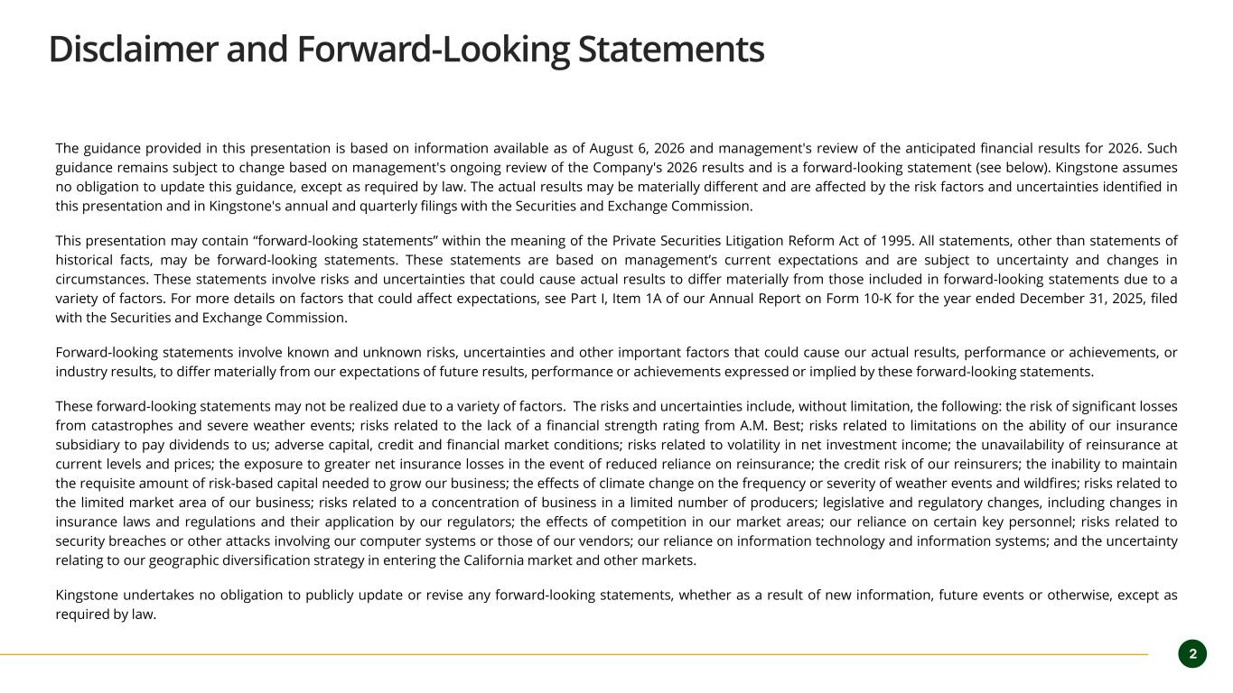
Disclaimer and Forward-Looking Statements The guidance provided in this presentation is based on information available as of August 6, 2026 and management's review of the anticipated financial results for 2026. Such guidance remains subject to change based on management's ongoing review of the Company's 2026 results and is a forward-looking statement (see below). Kingstone assumes no obligation to update this guidance, except as required by law. The actual results may be materially different and are affected by the risk factors and uncertainties identified in this presentation and in Kingstone's annual and quarterly filings with the Securities and Exchange Commission. This presentation may contain “forward-looking statements” within the meaning of the Private Securities Litigation Reform Act of 1995. All statements, other than statements of historical facts, may be forward-looking statements. These statements are based on management’s current expectations and are subject to uncertainty and changes in circumstances. These statements involve risks and uncertainties that could cause actual results to differ materially from those included in forward-looking statements due to a variety of factors. For more details on factors that could affect expectations, see Part I, Item 1A of our Annual Report on Form 10-K for the year ended December 31, 2025, filed with the Securities and Exchange Commission. Forward-looking statements involve known and unknown risks, uncertainties and other important factors that could cause our actual results, performance or achievements, or industry results, to differ materially from our expectations of future results, performance or achievements expressed or implied by these forward-looking statements. These forward-looking statements may not be realized due to a variety of factors. The risks and uncertainties include, without limitation, the following: the risk of significant losses from catastrophes and severe weather events; risks related to the lack of a financial strength rating from A.M. Best; risks related to limitations on the ability of our insurance subsidiary to pay dividends to us; adverse capital, credit and financial market conditions; risks related to volatility in net investment income; the unavailability of reinsurance at current levels and prices; the exposure to greater net insurance losses in the event of reduced reliance on reinsurance; the credit risk of our reinsurers; the inability to maintain the requisite amount of risk-based capital needed to grow our business; the effects of climate change on the frequency or severity of weather events and wildfires; risks related to the limited market area of our business; risks related to a concentration of business in a limited number of producers; legislative and regulatory changes, including changes in insurance laws and regulations and their application by our regulators; the effects of competition in our market areas; our reliance on certain key personnel; risks related to security breaches or other attacks involving our computer systems or those of our vendors; our reliance on information technology and information systems; and the uncertainty relating to our geographic diversification strategy in entering the California market and other markets. Kingstone undertakes no obligation to publicly update or revise any forward-looking statements, whether as a result of new information, future events or otherwise, except as required by law. 2

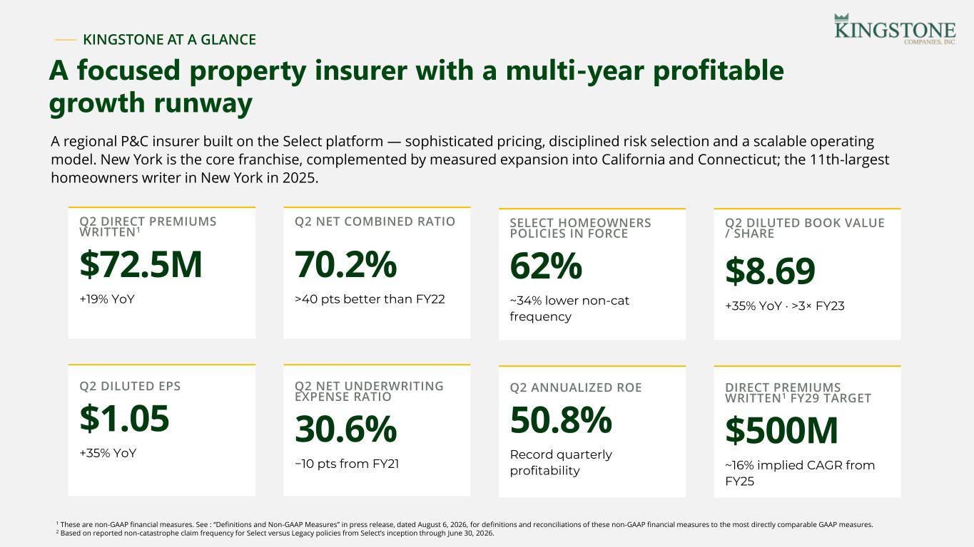
KINGSTONE AT A GLANCE A focused property insurer with a multi-year profitable growth runway Q2 DIRECT PREMIUMS WRITTEN1 $72.5M +19% YoY Q2 NET COMBINED RATIO 70.2% >40 pts better than FY22 SELECT HOMEOWNERS POLICIES IN FORCE 62% ~34% lower non-cat frequency Q2 DILUTED BOOK VALUE / SHARE $8.69 +35% YoY · >3× FY23 Q2 DILUTED EPS $1.05 +35% YoY Q2 NET UNDERWRITING EXPENSE RATIO 30.6% −10 pts from FY21 Q2 ANNUALIZED ROE 50.8% Record quarterly profitability DIRECT PREMIUMS WRITTEN1 FY29 TARGET $500M ~16% implied CAGR from FY25 A regional P&C insurer built on the Select platform — sophisticated pricing, disciplined risk selection and a scalable operating model. New York is the core franchise, complemented by measured expansion into California and Connecticut; the 11th-largest homeowners writer in New York in 2025. 1 These are non-GAAP financial measures. See : “Definitions and Non-GAAP Measures” in press release, dated August 6, 2026, for definitions and reconciliations of these non-GAAP financial measures to the most directly comparable GAAP measures. 2 Based on reported non-catastrophe claim frequency for Select versus Legacy policies from Select’s inception through June 30, 2026.

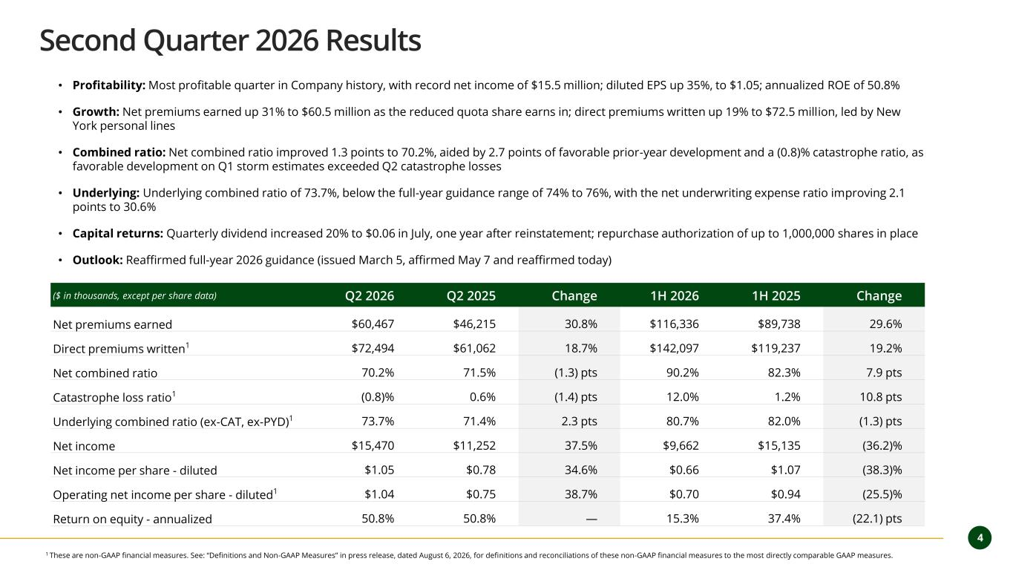
4 Second Quarter 2026 Results • Profitability: Most profitable quarter in Company history, with record net income of $15.5 million; diluted EPS up 35%, to $1.05; annualized ROE of 50.8% • Growth: Net premiums earned up 31% to $60.5 million as the reduced quota share earns in; direct premiums written up 19% to $72.5 million, led by New York personal lines • Combined ratio: Net combined ratio improved 1.3 points to 70.2%, aided by 2.7 points of favorable prior-year development and a (0.8)% catastrophe ratio, as favorable development on Q1 storm estimates exceeded Q2 catastrophe losses • Underlying: Underlying combined ratio of 73.7%, below the full-year guidance range of 74% to 76%, with the net underwriting expense ratio improving 2.1 points to 30.6% • Capital returns: Quarterly dividend increased 20% to $0.06 in July, one year after reinstatement; repurchase authorization of up to 1,000,000 shares in place • Outlook: Reaffirmed full-year 2026 guidance (issued March 5, affirmed May 7 and reaffirmed today) 1 These are non-GAAP financial measures. See: “Definitions and Non-GAAP Measures” in press release, dated August 6, 2026, for definitions and reconciliations of these non-GAAP financial measures to the most directly comparable GAAP measures. ($ in thousands, except per share data) Q2 2026 Q2 2025 Change 1H 2026 1H 2025 Change Net premiums earned $60,467 $46,215 30.8% $116,336 $89,738 29.6% Direct premiums written1 $72,494 $61,062 18.7% $142,097 $119,237 19.2% Net combined ratio 70.2% 71.5% (1.3) pts 90.2% 82.3% 7.9 pts Catastrophe loss ratio1 (0.8)% 0.6% (1.4) pts 12.0% 1.2% 10.8 pts Underlying combined ratio (ex-CAT, ex-PYD)1 73.7% 71.4% 2.3 pts 80.7% 82.0% (1.3) pts Net income $15,470 $11,252 37.5% $9,662 $15,135 (36.2)% Net income per share - diluted $1.05 $0.78 34.6% $0.66 $1.07 (38.3)% Operating net income per share - diluted1 $1.04 $0.75 38.7% $0.70 $0.94 (25.5)% Return on equity - annualized 50.8% 50.8% — 15.3% 37.4% (22.1) pts

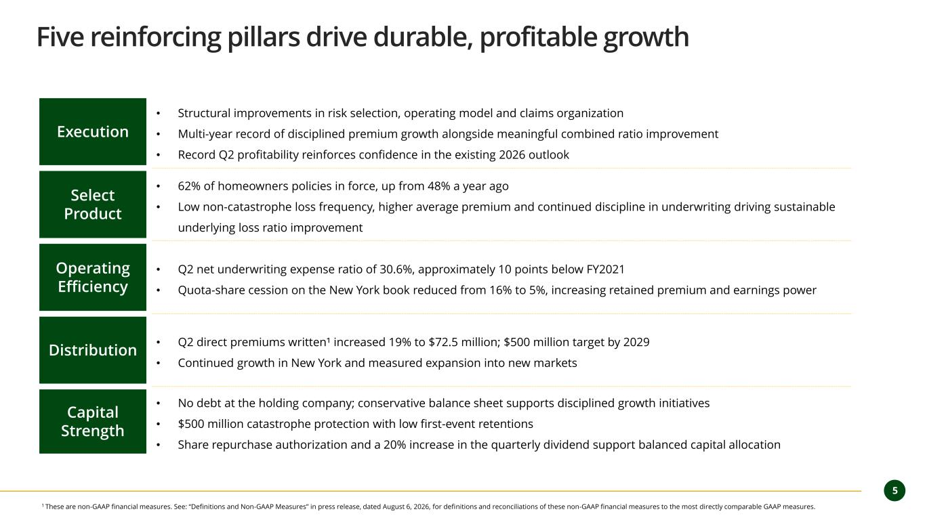
5 Five reinforcing pillars drive durable, profitable growth Execution • Structural improvements in risk selection, operating model and claims organization • Multi-year record of disciplined premium growth alongside meaningful combined ratio improvement • Record Q2 profitability reinforces confidence in the existing 2026 outlook Select Product • 62% of homeowners policies in force, up from 48% a year ago • Low non-catastrophe loss frequency, higher average premium and continued discipline in underwriting driving sustainable underlying loss ratio improvement Operating Efficiency • Q2 net underwriting expense ratio of 30.6%, approximately 10 points below FY2021 • Quota-share cession on the New York book reduced from 16% to 5%, increasing retained premium and earnings power Distribution • Q2 direct premiums written¹ increased 19% to $72.5 million; $500 million target by 2029 • Continued growth in New York and measured expansion into new markets Capital Strength • No debt at the holding company; conservative balance sheet supports disciplined growth initiatives • $500 million catastrophe protection with low first-event retentions • Share repurchase authorization and a 20% increase in the quarterly dividend support balanced capital allocation 1 These are non-GAAP financial measures. See: “Definitions and Non-GAAP Measures” in press release, dated August 6, 2026, for definitions and reconciliations of these non-GAAP financial measures to the most directly comparable GAAP measures.

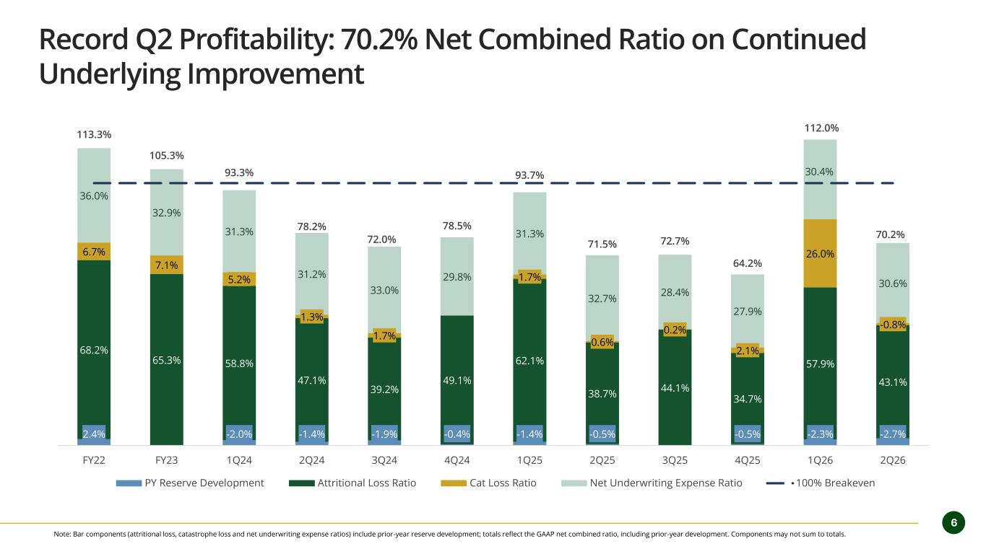
6 Record Q2 Profitability: 70.2% Net Combined Ratio on Continued Underlying Improvement Note: Bar components (attritional loss, catastrophe loss and net underwriting expense ratios) include prior-year reserve development; totals reflect the GAAP net combined ratio, including prior-year development. Components may not sum to totals. 2.4% -2.0% -1.4% -1.9% -0.4% -1.4% -0.5% -0.5% -2.3% -2.7% 68.2% 65.3% 58.8% 47.1% 39.2% 49.1% 62.1% 38.7% 44.1% 34.7% 57.9% 43.1% 6.7% 7.1% 5.2% 1.3% 1.7% 1.7% 0.6% 0.2% 2.1% 26.0% -0.8% 36.0% 32.9% 31.3% 31.2% 33.0% 29.8% 31.3% 32.7% 28.4% 27.9% 30.4% 30.6% 113.3% 105.3% 93.3% 78.2% 72.0% 78.5% 93.7% 71.5% 72.7% 64.2% 112.0% 70.2% FY22 FY23 1Q24 2Q24 3Q24 4Q24 1Q25 2Q25 3Q25 4Q25 1Q26 2Q26 PY Reserve Development Attritional Loss Ratio Cat Loss Ratio Net Underwriting Expense Ratio 100% Breakeven

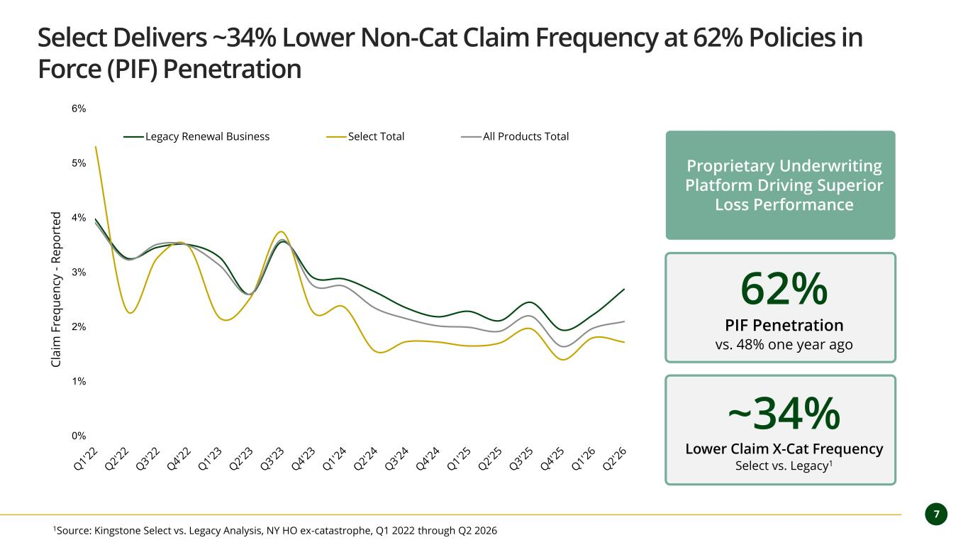
7 Select Delivers ~34% Lower Non-Cat Claim Frequency at 62% Policies in Force (PIF) Penetration 0% 1% 2% 3% 4% 5% 6% C la im F re q u e n cy - R e p o rt e d Legacy Renewal Business Select Total All Products Total 62% PIF Penetration vs. 48% one year ago 1Source: Kingstone Select vs. Legacy Analysis, NY HO ex-catastrophe, Q1 2022 through Q2 2026 ~34% Lower Claim X-Cat Frequency Select vs. Legacy1 Proprietary Underwriting Platform Driving Superior Loss Performance

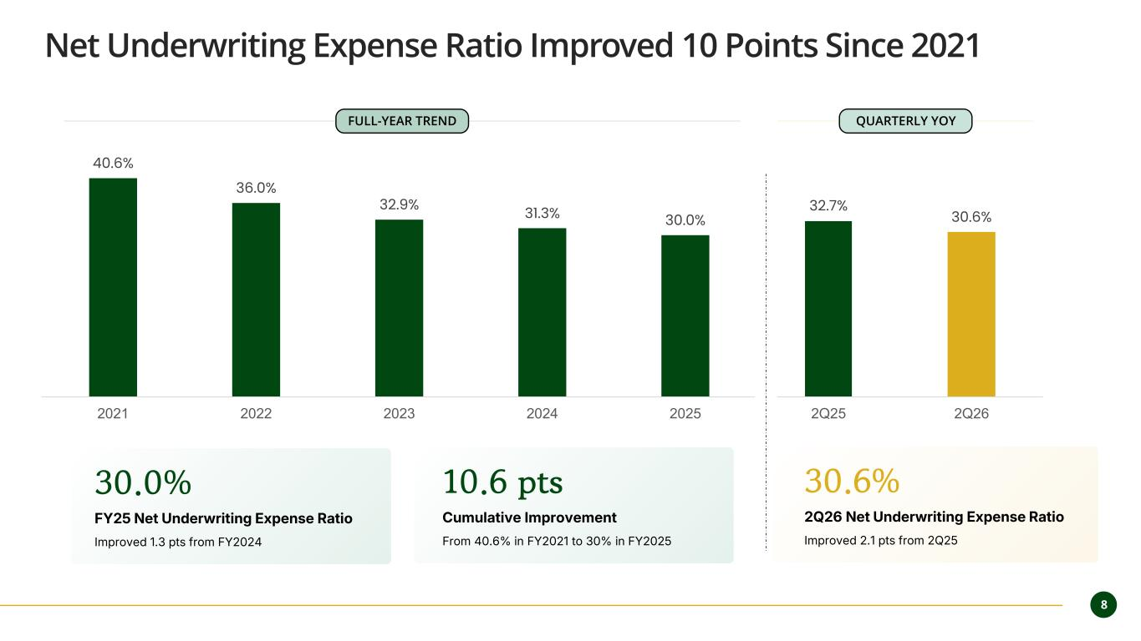
8 40.6% 36.0% 32.9% 31.3% 30.0% 32.7% 30.6% 2021 2022 2023 2024 2025 2Q25 2Q26 Net Underwriting Expense Ratio Improved 10 Points Since 2021 30.0% FY25 Net Underwriting Expense Ratio Improved 1.3 pts from FY2024 30.6% 2Q26 Net Underwriting Expense Ratio Improved 2.1 pts from 2Q25 10.6 pts Cumulative Improvement From 40.6% in FY2021 to 30% in FY2025 FULL-YEAR TREND QUARTERLY YOY

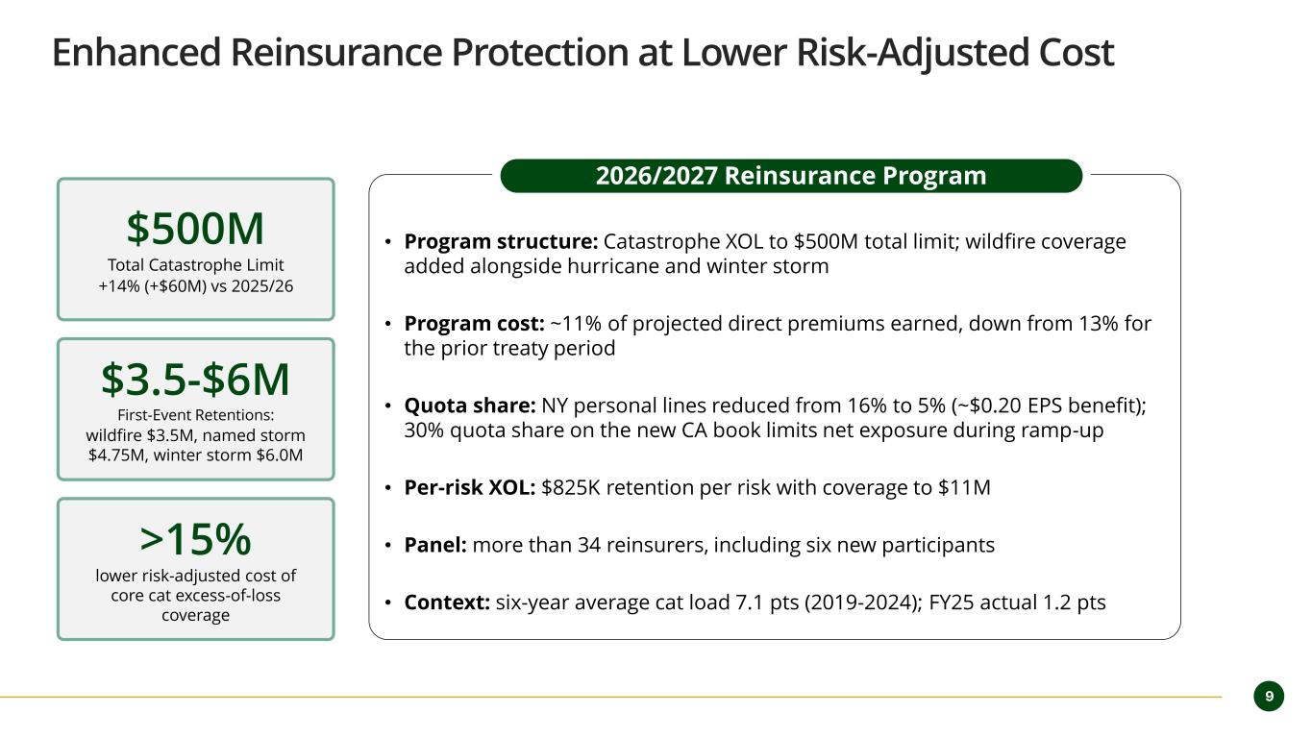
9 Enhanced Reinsurance Protection at Lower Risk-Adjusted Cost $500M Total Catastrophe Limit +14% (+$60M) vs 2025/26 • Program structure: Catastrophe XOL to $500M total limit; wildfire coverage added alongside hurricane and winter storm • Program cost: ~11% of projected direct premiums earned, down from 13% for the prior treaty period • Quota share: NY personal lines reduced from 16% to 5% (~$0.20 EPS benefit); 30% quota share on the new CA book limits net exposure during ramp-up • Per-risk XOL: $825K retention per risk with coverage to $11M • Panel: more than 34 reinsurers, including six new participants • Context: six-year average cat load 7.1 pts (2019-2024); FY25 actual 1.2 pts $3.5-$6M First-Event Retentions: wildfire $3.5M, named storm $4.75M, winter storm $6.0M >15% lower risk-adjusted cost of core cat excess-of-loss coverage 2026/2027 Reinsurance Program

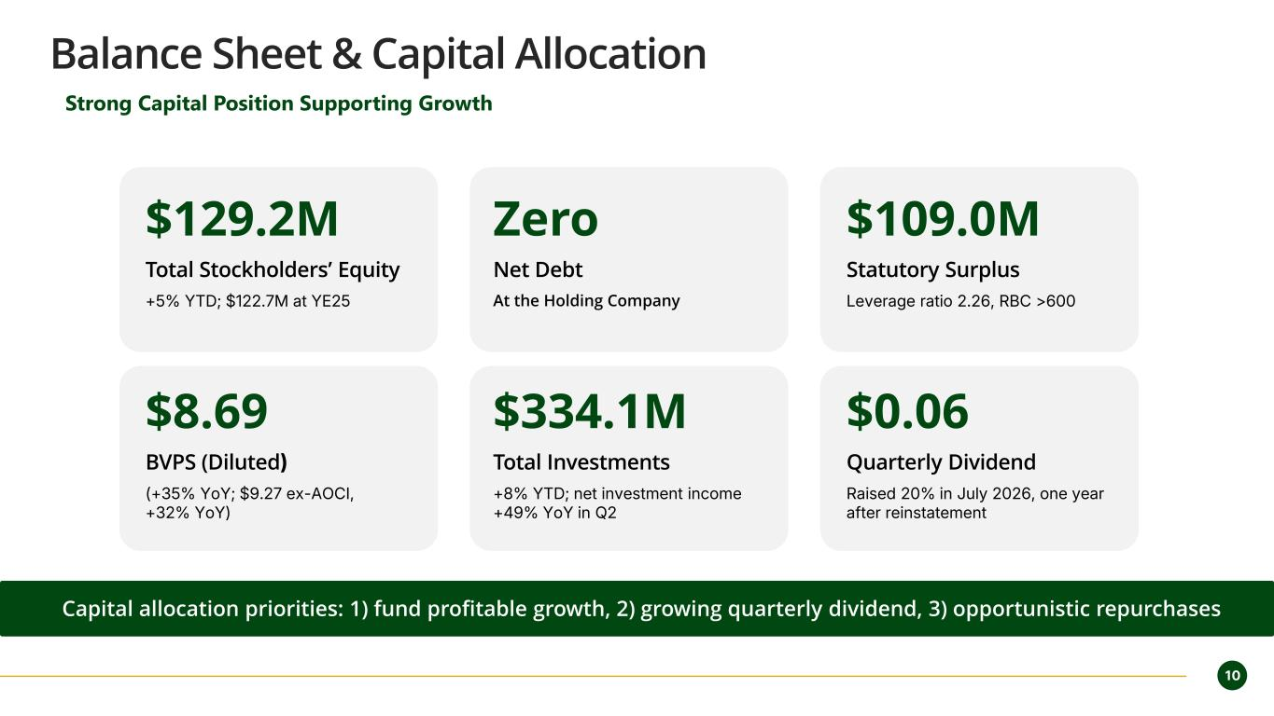
10 Balance Sheet & Capital Allocation Strong Capital Position Supporting Growth $129.2M Total Stockholders’ Equity +5% YTD; $122.7M at YE25 Zero Net Debt At the Holding Company $109.0M Statutory Surplus Leverage ratio 2.26, RBC >600 $8.69 BVPS (Diluted) (+35% YoY; $9.27 ex-AOCI, +32% YoY) $334.1M Total Investments +8% YTD; net investment income +49% YoY in Q2 $0.06 Quarterly Dividend Raised 20% in July 2026, one year after reinstatement Capital allocation priorities: 1) fund profitable growth, 2) growing quarterly dividend, 3) opportunistic repurchases

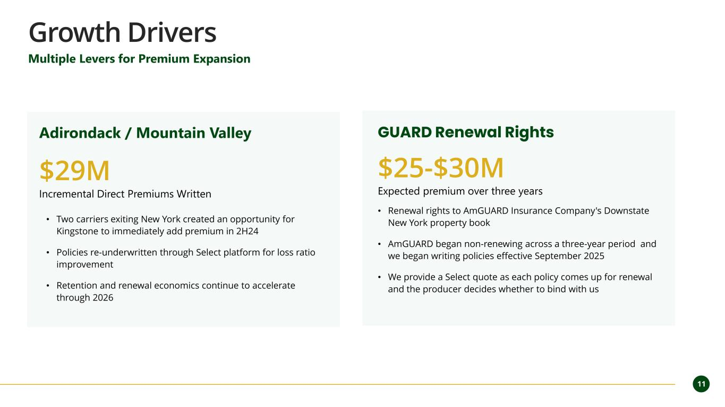
11 Growth Drivers Multiple Levers for Premium Expansion Adirondack / Mountain Valley $29M Incremental Direct Premiums Written • Two carriers exiting New York created an opportunity for Kingstone to immediately add premium in 2H24 • Policies re-underwritten through Select platform for loss ratio improvement • Retention and renewal economics continue to accelerate through 2026 GUARD Renewal Rights $25-$30M Expected premium over three years • Renewal rights to AmGUARD Insurance Company's Downstate New York property book • AmGUARD began non-renewing across a three-year period and we began writing policies effective September 2025 • We provide a Select quote as each policy comes up for renewal and the producer decides whether to bind with us

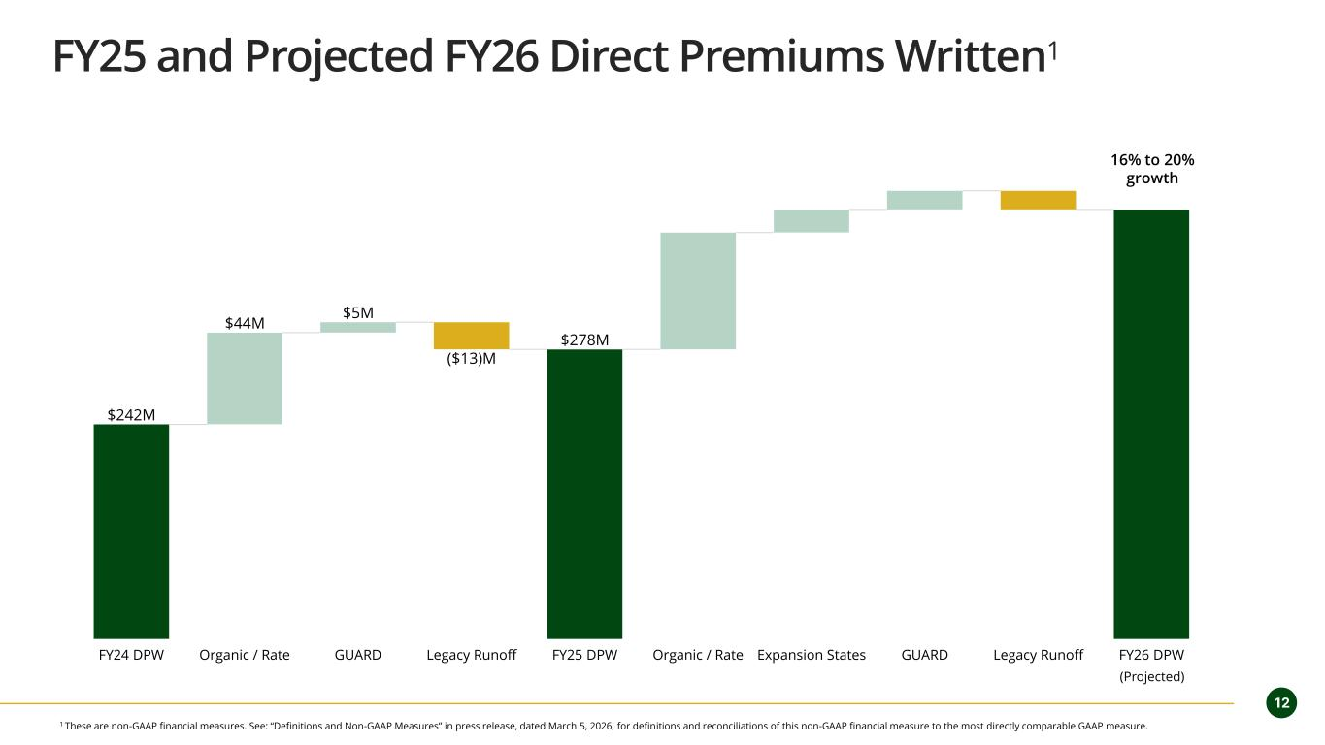
12 FY25 and Projected FY26 Direct Premiums Written1 $242M $44M $5M $278M ($13)M FY24 DPW Organic / Rate GUARD Legacy Runoff FY25 DPW Organic / Rate Expansion States GUARD Legacy Runoff FY26 DPW 16% to 20% growth (Projected) 1 These are non-GAAP financial measures. See: “Definitions and Non-GAAP Measures” in press release, dated March 5, 2026, for definitions and reconciliations of this non-GAAP financial measure to the most directly comparable GAAP measure.

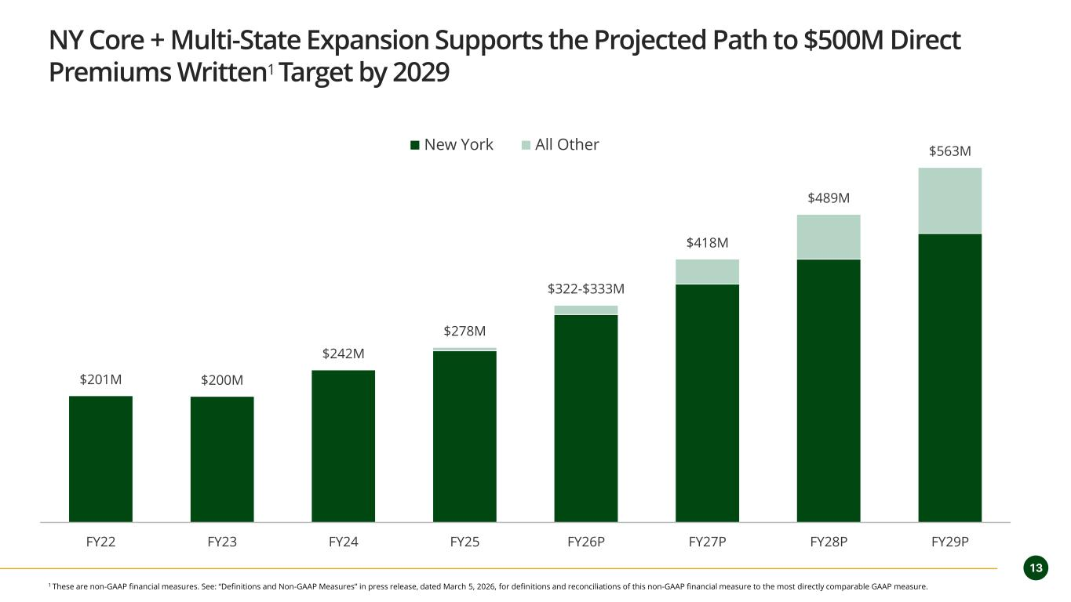
13 NY Core + Multi-State Expansion Supports the Projected Path to $500M Direct Premiums Written1 Target by 2029 $201M $200M $242M $278M $322-$333M $418M $489M $563M $0M $100M $200M $300M $400M $500M $600M FY22 FY23 FY24 FY25 FY26P FY27P FY28P FY29P New York All Other 1 These are non-GAAP financial measures. See: “Definitions and Non-GAAP Measures” in press release, dated March 5, 2026, for definitions and reconciliations of this non-GAAP financial measure to the most directly comparable GAAP measure.

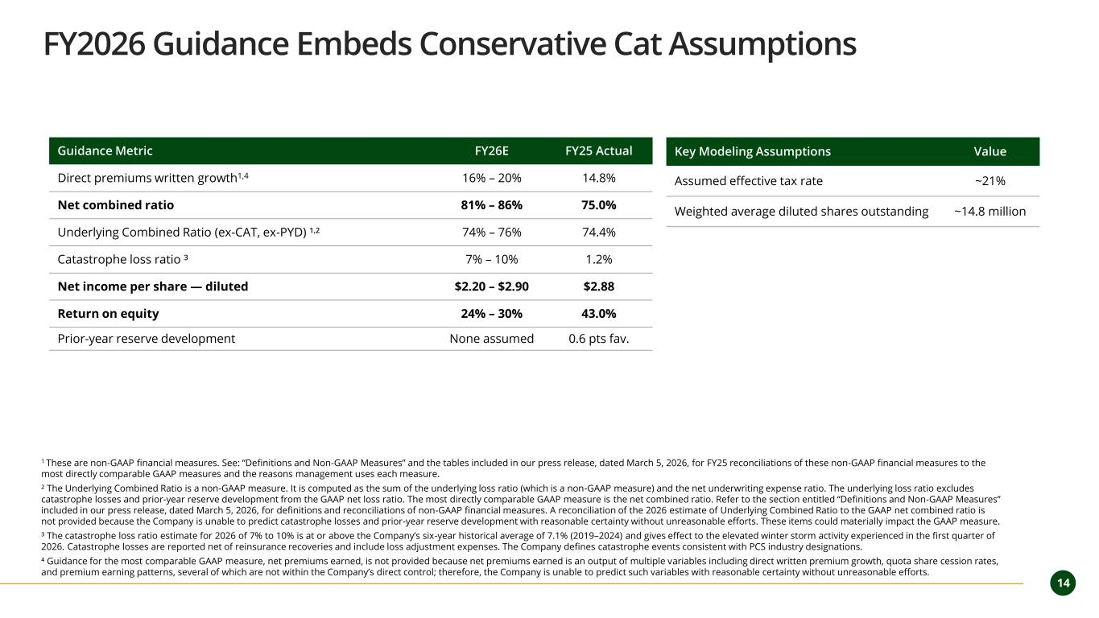
14 FY2026 Guidance Embeds Conservative Cat Assumptions 1 These are non-GAAP financial measures. See: “Definitions and Non-GAAP Measures” and the tables included in our press release, dated March 5, 2026, for FY25 reconciliations of these non-GAAP financial measures to the most directly comparable GAAP measures and the reasons management uses each measure. ² The Underlying Combined Ratio is a non-GAAP measure. It is computed as the sum of the underlying loss ratio (which is a non-GAAP measure) and the net underwriting expense ratio. The underlying loss ratio excludes catastrophe losses and prior-year reserve development from the GAAP net loss ratio. The most directly comparable GAAP measure is the net combined ratio. Refer to the section entitled “Definitions and Non-GAAP Measures” included in our press release, dated March 5, 2026, for definitions and reconciliations of non-GAAP financial measures. A reconciliation of the 2026 estimate of Underlying Combined Ratio to the GAAP net combined ratio is not provided because the Company is unable to predict catastrophe losses and prior-year reserve development with reasonable certainty without unreasonable efforts. These items could materially impact the GAAP measure. ³ The catastrophe loss ratio estimate for 2026 of 7% to 10% is at or above the Company’s six-year historical average of 7.1% (2019–2024) and gives effect to the elevated winter storm activity experienced in the first quarter of 2026. Catastrophe losses are reported net of reinsurance recoveries and include loss adjustment expenses. The Company defines catastrophe events consistent with PCS industry designations. ⁴ Guidance for the most comparable GAAP measure, net premiums earned, is not provided because net premiums earned is an output of multiple variables including direct written premium growth, quota share cession rates, and premium earning patterns, several of which are not within the Company’s direct control; therefore, the Company is unable to predict such variables with reasonable certainty without unreasonable efforts. Guidance Metric FY26E FY25 Actual Direct premiums written growth1,4 16% – 20% 14.8% Net combined ratio 81% – 86% 75.0% Underlying Combined Ratio (ex-CAT, ex-PYD) ¹,² 74% – 76% 74.4% Catastrophe loss ratio ³ 7% – 10% 1.2% Net income per share — diluted $2.20 – $2.90 $2.88 Return on equity 24% – 30% 43.0% Prior-year reserve development None assumed 0.6 pts fav. Key Modeling Assumptions Value Assumed effective tax rate ~21% Weighted average diluted shares outstanding ~14.8 million

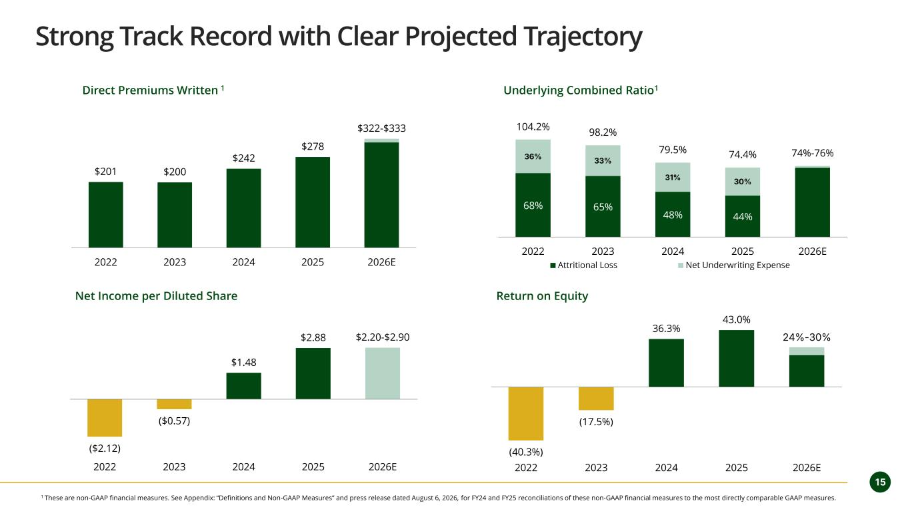
15 Strong Track Record with Clear Projected Trajectory $201 $200 $242 $278 $322-$333 2022 2023 2024 2025 2026E 68% 65% 48% 44% 36% 33% 31% 30% 104.2% 98.2% 79.5% 74.4% 74%-76% 0 2022 2023 2024 2025 2026E Attritional Loss Net Underwriting Expense ($2.12) ($0.57) $1.48 $2.88 $2.20-$2.90 2022 2023 2024 2025 2026E (40.3%) (17.5%) 36.3% 43.0% 24%-30% 2022 2023 2024 2025 2026E Direct Premiums Written 1 Underlying Combined Ratio1 Net Income per Diluted Share Return on Equity 1 These are non-GAAP financial measures. See Appendix: “Definitions and Non-GAAP Measures” and press release dated August 6, 2026, for FY24 and FY25 reconciliations of these non-GAAP financial measures to the most directly comparable GAAP measures.


16 Executive Management Team Meryl S. Golden President & Chief Executive Officer 30+ years Joined 2019 as COO; appointed CEO Oct 2023 Progressive · Liberty Mutual · Earnix · Bridgewater Randy L. Patten Vice President & Chief Financial Officer 25+ years Joined Aug 2025; led finance through NEXT Insurance's $2.6B acquisition NEXT Insurance · United Fire Group · Transamerica Sarah (Minlei) Chen SVP, Chief Actuary & Head of Product Mgmt 10+ years Joined Nov 2020; product development and actuarial pricing Homesite · Plymouth Rock · Travelers David Fernandez Senior Vice President & Chief Claims Officer 25+ years Joined Nov 2023; led 1,000+ claims professionals at prior carriers Progressive · Liberty Mutual · Point32Health 90+ Years Combined Insurance Leadership 30+ YEARS 25+ YEARS 10+ YEARS 25+ YEARS


17 Appendix

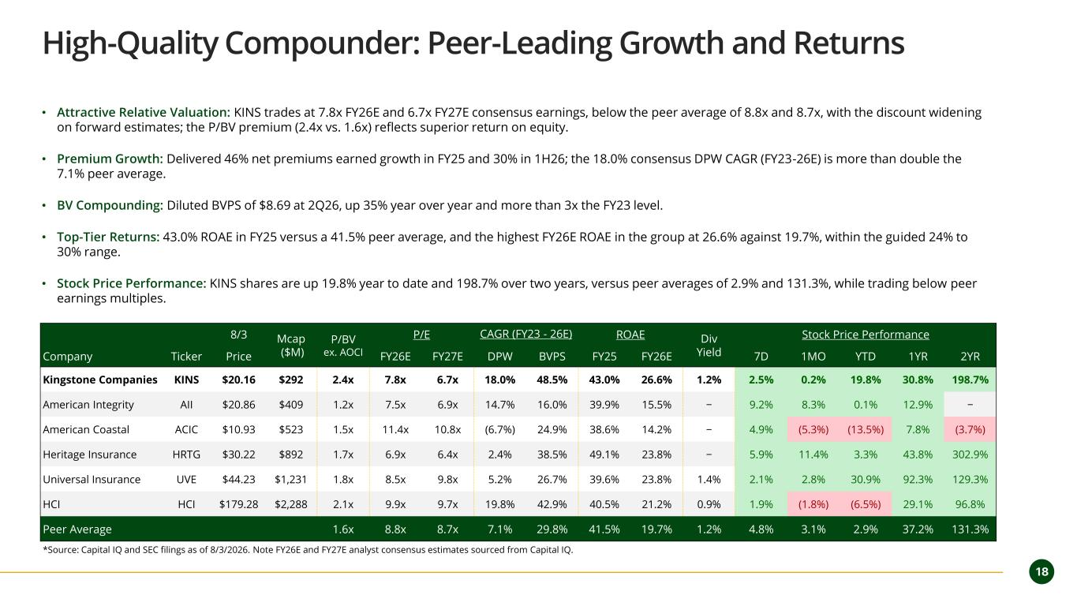
18 High-Quality Compounder: Peer-Leading Growth and Returns • Attractive Relative Valuation: KINS trades at 7.8x FY26E and 6.7x FY27E consensus earnings, below the peer average of 8.8x and 8.7x, with the discount widening on forward estimates; the P/BV premium (2.4x vs. 1.6x) reflects superior return on equity. • Premium Growth: Delivered 46% net premiums earned growth in FY25 and 30% in 1H26; the 18.0% consensus DPW CAGR (FY23-26E) is more than double the 7.1% peer average. • BV Compounding: Diluted BVPS of $8.69 at 2Q26, up 35% year over year and more than 3x the FY23 level. • Top-Tier Returns: 43.0% ROAE in FY25 versus a 41.5% peer average, and the highest FY26E ROAE in the group at 26.6% against 19.7%, within the guided 24% to 30% range. • Stock Price Performance: KINS shares are up 19.8% year to date and 198.7% over two years, versus peer averages of 2.9% and 131.3%, while trading below peer earnings multiples. 8/3 Mcap ($M) P/BV ex. AOCI P/E CAGR (FY23 - 26E) ROAE Div Yield Stock Price Performance Company Ticker Price FY26E FY27E DPW BVPS FY25 FY26E 7D 1MO YTD 1YR 2YR Kingstone Companies KINS $20.16 $292 2.4x 7.8x 6.7x 18.0% 48.5% 43.0% 26.6% 1.2% 2.5% 0.2% 19.8% 30.8% 198.7% American Integrity AII $20.86 $409 1.2x 7.5x 6.9x 14.7% 16.0% 39.9% 15.5% − 9.2% 8.3% 0.1% 12.9% − American Coastal ACIC $10.93 $523 1.5x 11.4x 10.8x (6.7%) 24.9% 38.6% 14.2% − 4.9% (5.3%) (13.5%) 7.8% (3.7%) Heritage Insurance HRTG $30.22 $892 1.7x 6.9x 6.4x 2.4% 38.5% 49.1% 23.8% − 5.9% 11.4% 3.3% 43.8% 302.9% Universal Insurance UVE $44.23 $1,231 1.8x 8.5x 9.8x 5.2% 26.7% 39.6% 23.8% 1.4% 2.1% 2.8% 30.9% 92.3% 129.3% HCI HCI $179.28 $2,288 2.1x 9.9x 9.7x 19.8% 42.9% 40.5% 21.2% 0.9% 1.9% (1.8%) (6.5%) 29.1% 96.8% Peer Average 1.6x 8.8x 8.7x 7.1% 29.8% 41.5% 19.7% 1.2% 4.8% 3.1% 2.9% 37.2% 131.3% *Source: Capital IQ and SEC filings as of 8/3/2026. Note FY26E and FY27E analyst consensus estimates sourced from Capital IQ.

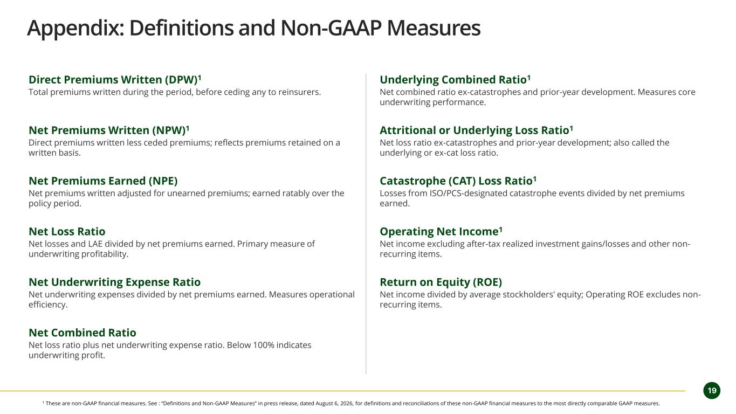
19 Appendix: Definitions and Non-GAAP Measures Direct Premiums Written (DPW)1 Total premiums written during the period, before ceding any to reinsurers. Net Premiums Written (NPW)1 Direct premiums written less ceded premiums; reflects premiums retained on a written basis. Net Premiums Earned (NPE) Net premiums written adjusted for unearned premiums; earned ratably over the policy period. Net Loss Ratio Net losses and LAE divided by net premiums earned. Primary measure of underwriting profitability. Net Underwriting Expense Ratio Net underwriting expenses divided by net premiums earned. Measures operational efficiency. Net Combined Ratio Net loss ratio plus net underwriting expense ratio. Below 100% indicates underwriting profit. Underlying Combined Ratio1 Net combined ratio ex-catastrophes and prior-year development. Measures core underwriting performance. Attritional or Underlying Loss Ratio1 Net loss ratio ex-catastrophes and prior-year development; also called the underlying or ex-cat loss ratio. Catastrophe (CAT) Loss Ratio1 Losses from ISO/PCS-designated catastrophe events divided by net premiums earned. Operating Net Income1 Net income excluding after-tax realized investment gains/losses and other non- recurring items. Return on Equity (ROE) Net income divided by average stockholders' equity; Operating ROE excludes non- recurring items. 1 These are non-GAAP financial measures. See : “Definitions and Non-GAAP Measures” in press release, dated August 6, 2026, for definitions and reconciliations of these non-GAAP financial measures to the most directly comparable GAAP measures.

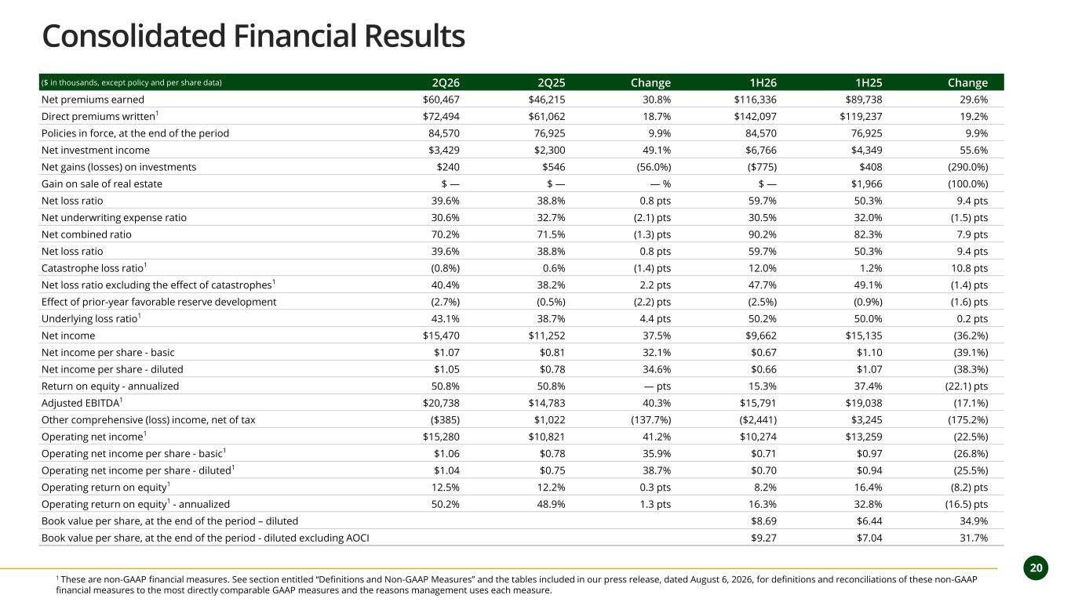
2 0 20 Consolidated Financial Results 1 These are non-GAAP financial measures. See section entitled “Definitions and Non-GAAP Measures” and the tables included in our press release, dated August 6, 2026, for definitions and reconciliations of these non-GAAP financial measures to the most directly comparable GAAP measures and the reasons management uses each measure. ($ in thousands, except policy and per share data) 2Q26 2Q25 Change 1H26 1H25 Change Net premiums earned $60,467 $46,215 30.8% $116,336 $89,738 29.6% Direct premiums written1 $72,494 $61,062 18.7% $142,097 $119,237 19.2% Policies in force, at the end of the period 84,570 76,925 9.9% 84,570 76,925 9.9% Net investment income $3,429 $2,300 49.1% $6,766 $4,349 55.6% Net gains (losses) on investments $240 $546 (56.0%) ($775) $408 (290.0%) Gain on sale of real estate $ — $ — — % $ — $1,966 (100.0%) Net loss ratio 39.6% 38.8% 0.8 pts 59.7% 50.3% 9.4 pts Net underwriting expense ratio 30.6% 32.7% (2.1) pts 30.5% 32.0% (1.5) pts Net combined ratio 70.2% 71.5% (1.3) pts 90.2% 82.3% 7.9 pts Net loss ratio 39.6% 38.8% 0.8 pts 59.7% 50.3% 9.4 pts Catastrophe loss ratio1 (0.8%) 0.6% (1.4) pts 12.0% 1.2% 10.8 pts Net loss ratio excluding the effect of catastrophes1 40.4% 38.2% 2.2 pts 47.7% 49.1% (1.4) pts Effect of prior-year favorable reserve development (2.7%) (0.5%) (2.2) pts (2.5%) (0.9%) (1.6) pts Underlying loss ratio1 43.1% 38.7% 4.4 pts 50.2% 50.0% 0.2 pts Net income $15,470 $11,252 37.5% $9,662 $15,135 (36.2%) Net income per share - basic $1.07 $0.81 32.1% $0.67 $1.10 (39.1%) Net income per share - diluted $1.05 $0.78 34.6% $0.66 $1.07 (38.3%) Return on equity - annualized 50.8% 50.8% — pts 15.3% 37.4% (22.1) pts Adjusted EBITDA1 $20,738 $14,783 40.3% $15,791 $19,038 (17.1%) Other comprehensive (loss) income, net of tax ($385) $1,022 (137.7%) ($2,441) $3,245 (175.2%) Operating net income1 $15,280 $10,821 41.2% $10,274 $13,259 (22.5%) Operating net income per share - basic1 $1.06 $0.78 35.9% $0.71 $0.97 (26.8%) Operating net income per share - diluted1 $1.04 $0.75 38.7% $0.70 $0.94 (25.5%) Operating return on equity1 12.5% 12.2% 0.3 pts 8.2% 16.4% (8.2) pts Operating return on equity1 - annualized 50.2% 48.9% 1.3 pts 16.3% 32.8% (16.5) pts Book value per share, at the end of the period – diluted $8.69 $6.44 34.9% Book value per share, at the end of the period - diluted excluding AOCI $9.27 $7.04 31.7%

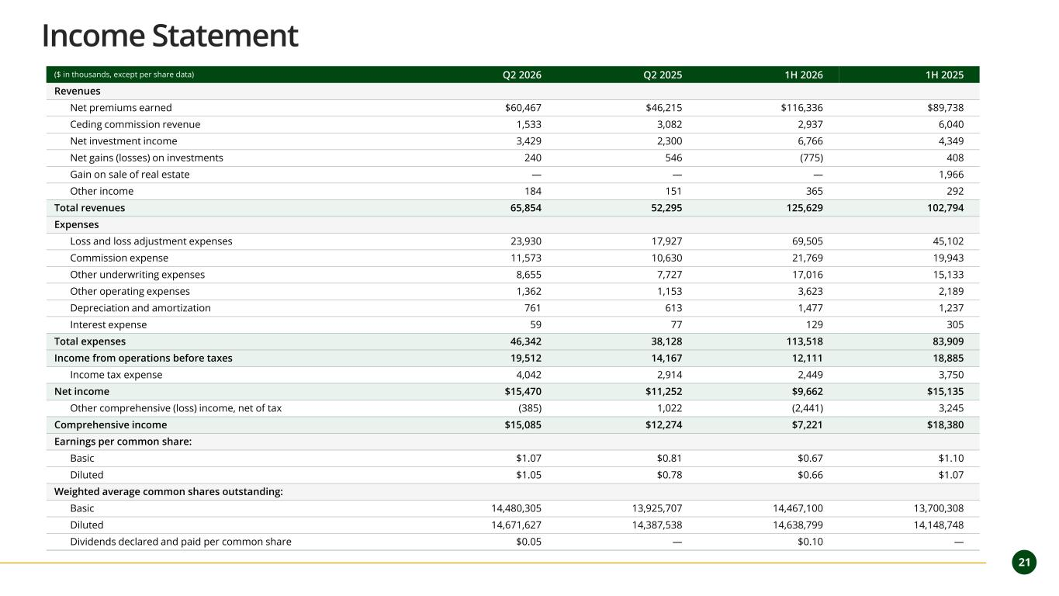
21 ($ in thousands, except per share data) Q2 2026 Q2 2025 1H 2026 1H 2025 Revenues Net premiums earned $60,467 $46,215 $116,336 $89,738 Ceding commission revenue 1,533 3,082 2,937 6,040 Net investment income 3,429 2,300 6,766 4,349 Net gains (losses) on investments 240 546 (775) 408 Gain on sale of real estate — — — 1,966 Other income 184 151 365 292 Total revenues 65,854 52,295 125,629 102,794 Expenses Loss and loss adjustment expenses 23,930 17,927 69,505 45,102 Commission expense 11,573 10,630 21,769 19,943 Other underwriting expenses 8,655 7,727 17,016 15,133 Other operating expenses 1,362 1,153 3,623 2,189 Depreciation and amortization 761 613 1,477 1,237 Interest expense 59 77 129 305 Total expenses 46,342 38,128 113,518 83,909 Income from operations before taxes 19,512 14,167 12,111 18,885 Income tax expense 4,042 2,914 2,449 3,750 Net income $15,470 $11,252 $9,662 $15,135 Other comprehensive (loss) income, net of tax (385) 1,022 (2,441) 3,245 Comprehensive income $15,085 $12,274 $7,221 $18,380 Earnings per common share: Basic $1.07 $0.81 $0.67 $1.10 Diluted $1.05 $0.78 $0.66 $1.07 Weighted average common shares outstanding: Basic 14,480,305 13,925,707 14,467,100 13,700,308 Diluted 14,671,627 14,387,538 14,638,799 14,148,748 Dividends declared and paid per common share $0.05 — $0.10 — Income Statement

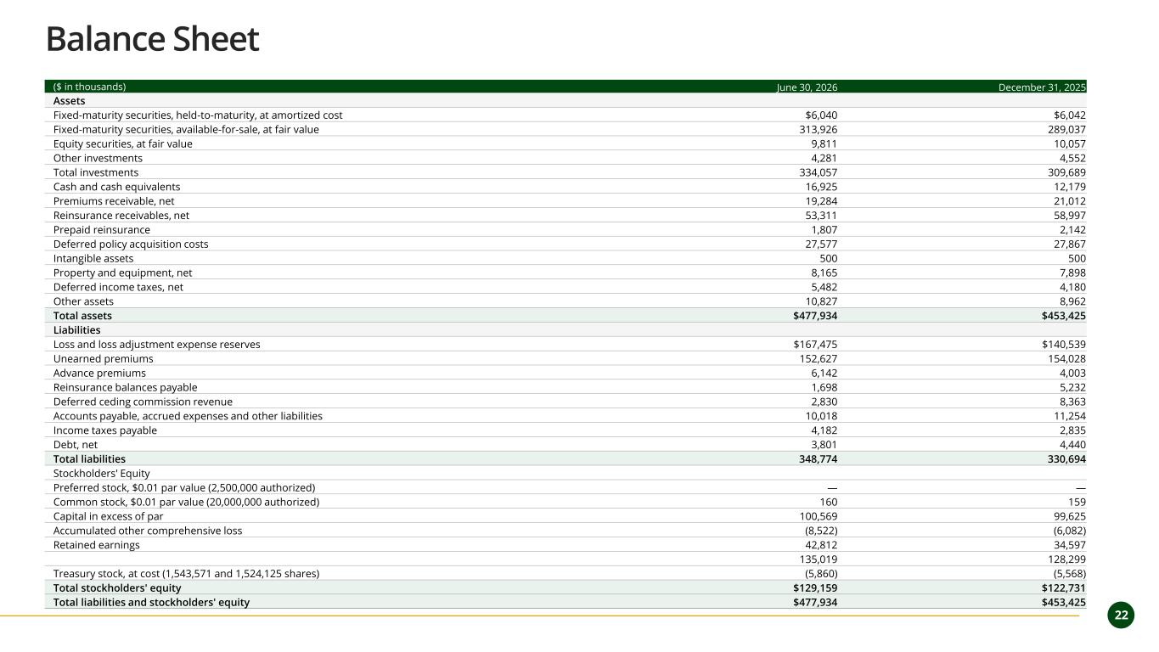
2 2 22 ($ in thousands) June 30, 2026 December 31, 2025 Assets Fixed-maturity securities, held-to-maturity, at amortized cost $6,040 $6,042 Fixed-maturity securities, available-for-sale, at fair value 313,926 289,037 Equity securities, at fair value 9,811 10,057 Other investments 4,281 4,552 Total investments 334,057 309,689 Cash and cash equivalents 16,925 12,179 Premiums receivable, net 19,284 21,012 Reinsurance receivables, net 53,311 58,997 Prepaid reinsurance 1,807 2,142 Deferred policy acquisition costs 27,577 27,867 Intangible assets 500 500 Property and equipment, net 8,165 7,898 Deferred income taxes, net 5,482 4,180 Other assets 10,827 8,962 Total assets $477,934 $453,425 Liabilities Loss and loss adjustment expense reserves $167,475 $140,539 Unearned premiums 152,627 154,028 Advance premiums 6,142 4,003 Reinsurance balances payable 1,698 5,232 Deferred ceding commission revenue 2,830 8,363 Accounts payable, accrued expenses and other liabilities 10,018 11,254 Income taxes payable 4,182 2,835 Debt, net 3,801 4,440 Total liabilities 348,774 330,694 Stockholders' Equity Preferred stock, $0.01 par value (2,500,000 authorized) — — Common stock, $0.01 par value (20,000,000 authorized) 160 159 Capital in excess of par 100,569 99,625 Accumulated other comprehensive loss (8,522) (6,082) Retained earnings 42,812 34,597 135,019 128,299 Treasury stock, at cost (1,543,571 and 1,524,125 shares) (5,860) (5,568) Total stockholders' equity $129,159 $122,731 Total liabilities and stockholders' equity $477,934 $453,425 Balance Sheet



