UNITED STATES

SECURITIES AND EXCHANGE COMMISSION

Washington, D.C. 20549

SCHEDULE 14A

(Rule 14a-101)

INFORMATION REQUIRED IN PROXY STATEMENT

SCHEDULE 14A INFORMATION

Proxy Statement Pursuant to Section 14(a) of the Securities Exchange Act of 1934

(Amendment No. )

Filed by the Registrant

Filed by a Party other than the Registrant

☒

☐

Check the appropriate box:

- Preliminary Proxy Statement

- Confidential, For Use of the Commission Only (as permitted by Rule 14a-6(e)(2)) ☒ Definitive Proxy Statement
- Definitive Additional Materials

- Soliciting Material Pursuant to Section 240.14a-12

KINGSTONE COMPANIES, INC.

(Name of Registrant as Specified in its Charter)

(Name of Person(s) Filing Proxy Statement, if Other Than the Registrant)

Payment of Filing Fee (Check all boxes that apply):

- No fee required.

- Fee paid previously with preliminary materials.

- Fee computed on table in exhibit required by Item 25(b) per Exchange Act Rules 14a-6(i)(1) and 0-11.

KINGSTONE COMPANIES, INC.

120 Wood Road

Kingston, New York 12401

NOTICE OF ANNUAL MEETING OF STOCKHOLDERS

TO BE HELD ON AUGUST 5, 2026

To the Stockholders of Kingstone Companies, Inc.:

NOTICE IS HEREBY GIVEN that the Annual Meeting of Stockholders of Kingstone Companies, Inc., a Delaware corporation (the “Company” or “we”), will be held at 9:00 a.m., local time, on August 5, 2026. We have decided to hold this year’s annual meeting virtually via live audio webcast on the Internet. We believe hosting a virtual annual meeting enables greater stockholder attendance and participation from any location around the world, improves meeting efficiency and our ability to communicate effectively with our stockholders, and reduces the cost and environmental impact on our annual meeting. You will be able to attend the annual meeting, vote and submit your questions during the annual meeting by visiting www.virtualshareholdermeeting.com/KINS2026. You will not be able to attend the annual meeting in person. The annual meeting will be held for the following purposes:

- To elect six directors for the coming year.

- To ratify the selection of CBIZ CPAs P.C. as the Company’s independent registered public accounting firm for the fiscal year ending December 31, 2026.

- To hold a non-binding advisory vote to approve the Company’s executive compensation.

- To transact such other business as may properly come before the meeting.

Only stockholders of record at the close of business on June 12, 2026, are entitled to notice of and to vote at the meeting or at any adjournment thereof.

Important notice regarding the availability of Proxy Materials: We are sending a Notice of Internet Availability of Proxy Materials (the “Notice”) to our stockholders of record and beneficial owners, unless they have directed us to provide the materials in a different manner. The Notice provides instructions on how to access and review all of the important information contained in this proxy statement, as well as how to submit a proxy by telephone or over the Internet. If you receive the Notice and would still like to receive a printed copy of our proxy materials, instructions for requesting these materials are included in the Notice. The Company plans to mail the Notice to stockholders by June 25, 2026. The proxy statement and the Company’s Annual Report on Form 10-K for the fiscal year ended December 31, 2025 are available electronically to the Company’s stockholders of record as of the close of business on June 12, 2026 at www.proxyvote.com.

Floyd R. Tupper

Secretary

Kingston, New York

June 25, 2026


WHETHER OR NOT YOU PLAN TO ATTEND THE MEETING, PLEASE SUBMIT YOUR PROXY OR VOTING INSTRUCTIONS AS SOON AS POSSIBLE. FOR SPECIFIC INSTRUCTIONS ON HOW TO VOTE YOUR SHARES, PLEASE REFER TO THE INSTRUCTIONS IN THE NOTICE REGARDING THE AVAILABILITY OF PROXY MATERIALS YOU RECEIVED IN THE MAIL OR, IF YOU REQUESTED TO RECEIVE PRINTED PROXY MATERIALS, YOUR ENCLOSED PROXY CARD. ANY STOCKHOLDER MAY REVOKE A SUBMITTED PROXY AT ANY TIME BEFORE THE MEETING BY WRITTEN NOTICE TO SUCH EFFECT, BY SUBMITTING A SUBSEQUENTLY DATED PROXY OR BY ATTENDING THE MEETING AND VOTING ONLINE. THOSE VOTING BY INTERNET OR BY TELEPHONE MAY ALSO REVOKE THEIR PROXY BY VOTING ONLINE AT THE MEETING OR BY VOTING AND SUBMITTING THEIR PROXY AT A LATER TIME BY INTERNET OR BY TELEPHONE.

KINGSTONE COMPANIES, INC.

120 Wood Road

Kingston, New York 12401

____________________________

PROXY STATEMENT

____________________________

SOLICITING, VOTING AND REVOCABILITY OF PROXY

This proxy statement is being made available to all stockholders of record at the close of business on June 12, 2026 in connection with the solicitation by the Board of Directors of proxies to be voted at the Annual Meeting of Stockholders to be held on August 5, 2026, at 9:00 a.m., local time, or any adjournment thereof. Proxy materials for the Annual Meeting of Stockholders were made available to stockholders on or about June 25, 2026.

All shares represented by proxies duly executed and received will be voted on the matters presented at the meeting in accordance with the instructions specified in such proxies. Proxies so received without specified instructions will be voted as follows:

- FOR the nominees named in the proxy to our Board of Directors;

- FOR the ratification of the selection of CBIZ CPAs P.C. as our independent registered public accounting firm for the fiscal year ending December 31, 2026;

- FOR the approval of the compensation of our named executive officers.

If you are a beneficial owner of shares held in street name and you do not provide specific voting instructions to the organization that holds your shares, the organization will be prohibited under the current rules of the New York Stock Exchange from voting your shares on “non-routine” matters. This is commonly referred to as a “broker non-vote.” The election of directors and the advisory vote on the approval of executive compensation are considered “non-routine” matters and therefore may not be voted on by your bank or broker absent specific instructions from you. The ratification of the selection of our independent registered public accounting firm is a routine matter. Please instruct your bank or broker so your vote can be counted.

Our Board of Directors does not know of any other matters that may be brought before the meeting nor does it foresee or have reason to believe that the proxy holder will have to vote for substitute or alternate nominees to the Board of Directors. In the event that any other matter should come before the meeting or any nominee is not available for election, the person named in the enclosed proxy will have discretionary authority to vote all proxies not marked to the contrary with respect to such matters in accordance with her best judgment.

The total number of shares of common stock outstanding and entitled to vote as of the close of business on June 12, 2026 was 14,484,841. Our common stock is the only class of securities entitled to vote on matters presented to our stockholders, each share being entitled to one vote. A majority of the shares of common stock outstanding and entitled to vote as of the close of business on June 12, 2026, or 7,242,421 shares of common stock, must be present at the meeting online or by proxy in order to constitute a quorum for the transaction of business.

Our Restated Certificate of Incorporation provides for cumulative voting of shares for the election of directors. This means that each stockholder has the right to cumulate his or her votes and give to one or more nominees as many votes as equals the number of directors to be elected (six) multiplied by the number of shares he is entitled to vote. A stockholder may therefore cast his or her votes for one nominee or distribute them among two or more of the nominees; however, in order to cumulate votes, a stockholder must request a proxy card (as Internet and telephone voting will not be available for such purposes). Only stockholders of record as of the close of business on June 12, 2026 will be entitled to vote. With regard to the election of directors, votes may be cast in favor or withheld. The directors shall be elected by a plurality of the votes cast in favor. Accordingly, based upon there being six nominees, each person who receives one or more votes will be elected as a director. Votes withheld in connection with the election of one or more of the nominees for director will not be counted as votes cast for such individuals and may be voted for the other nominees.

Stockholders may expressly abstain from voting on Proposals 2 and 3 by so indicating on the proxy. Abstentions are counted as present in the tabulation of votes on Proposals 2 and 3. Since each of Proposals 2 and 3 requires the affirmative approval of a majority of the shares of common stock present online or represented by proxy at the meeting and entitled to vote (assuming a quorum is present at the meeting), abstentions will have the effect of a negative vote while broker non-votes will have no effect.

Any person giving a proxy in the form accompanying this proxy statement has the power to revoke it at any time before its exercise. The proxy may be revoked by filing with us written notice of revocation or a fully executed proxy bearing a later date. The proxy may also be revoked by affirmatively electing to vote online while in attendance at the meeting. However, a stockholder who attends the meeting need not revoke a proxy given and vote online unless the stockholder wishes to do so. Written revocations or amended proxies should be sent to us at 120 Wood Road, Kingston, New York 12401, Attention: Corporate Secretary. Those voting by Internet or by telephone may also revoke their proxy by voting online at the meeting or by voting and submitting their proxy at a later time by Internet or by telephone.

The proxy is being solicited by our Board of Directors. We will bear the cost of the solicitation of proxies, including the charges and expenses of brokerage firms and other custodians, nominees and fiduciaries for forwarding proxy materials to beneficial owners of our shares. Solicitations will be made primarily by Internet availability of proxy materials and by mail, but certain of our directors, officers or employees may solicit proxies in person or by telephone, telecopier or email without special compensation.

2

A list of stockholders entitled to vote at the meeting will be available for examination by any stockholder for any purpose germane to the meeting, during ordinary business hours, for ten days prior to the meeting, at our offices located at 120 Wood Road, Kingston, New York 12401, and also during the whole time of the meeting for inspection by any stockholder who is present. To contact us, stockholders should call (845) 802-7900.

EXECUTIVE COMPENSATION

Summary Compensation Table

The following table sets forth certain information concerning the compensation for the fiscal years ended December 31, 2025 and 2024 for certain executive officers, including our Chief Executive Officer (collectively, the “Named Executive Officers”)

 |  |  |  |  |  | Non-Equity
Name and Principal Position | Year | Salary | Bonus | Stock Awards(1) | Option | Incentive Plan | All Other |  | Total
 |  |  |  |  | Awards(1) | Compensation | Compensation |  | Total
Meryl S. Golden | 2025 | $550,000 | $687,500 | $ 607,600 (3) | $ - | $ - | $ 26,000 (9) | $ | 1,871,100
Chief Executive Officer
and President | 2024 | $500,000 | $496,358 | $ 136,500 (4) | $ - | $ - | $ 25,800 (10) | $ | 1,158,658
Sarah (Minlei) Chen | 2025 | $387,046 | $145,642 | $ 291,742 (5) | $ - | $ - | $ 14,000 (11) | $ | 838,430
Chief Actuary and
Senior Vice President,
Kingstone Insurance
Company | 2024 | $355,138 | $166,609 | $ 166,109 (6) | $ 12,400 (8) | $ - | $ 7,838 (11) | $ | 708,094
Randy L. Patten (2) | 2025 | $140,274 | $253,103 | $ 652,603 (7) | $ - | $ - | $ - | $ | 1,045,980
Vice President, Chief
Financial Officer and | 2024 | $ - | $ - | $ - | $ - | $ - | $ - | $ | -
Treasurer

_________

- Amounts reflect the aggregate grant date fair value of grants made in each respective fiscal year computed in accordance with stock-based accounting rules (FASB ASC Topic 718-Stock Compensation), excluding the effect of estimated forfeitures. Assumptions used in the calculations of these amounts are included in Note 12 to our consolidated financial statements included in our Annual Report on Form 10-K for the fiscal year ended December 31, 2025, available electronically to our stockholders.

- Mr. Patten was elected Vice President, Chief Financial Officer and Treasurer on August 25, 2025.

- In January 2025, Ms. Golden was granted 40,000 shares of restricted common stock under our 2024 Equity Participation Plan (the “2024 Plan”). Such grant vested to the extent of 20,000 shares on the first anniversary of the date of grant and will vest to the extent of 20,000 shares on December 31, 2026, subject to acceleration under certain circumstances.

3

- In January 2024, Ms. Golden was granted 64,085 shares of restricted common stock under our Amended and Restated 2014 Equity Participation Plan (the “2014 Plan”). Such grant vested on the first anniversary of the date of grant.

- In June 2025, Ms. Chen was granted 10,000 shares of restricted common stock under the 2024 Plan. Such grant vested to the extent of one-third on the date of grant and will vest to the extent of one-third on each of the first and second anniversaries of the date of grant, subject to acceleration under certain circumstances. In addition, in March 2026, Ms. Chen was granted 8,624 shares of restricted common stock under the 2024 Plan in consideration of services rendered during 2025. Such grant vested to the extent of one-third on the date of grant and will vest to the extent of one-third on each of the first and second anniversaries of the date of grant, subject to acceleration under certain circumstances.

- In March 2025, Ms. Chen was granted 10,935 shares of restricted common stock under the 2024 Plan in consideration of services rendered during 2024. Such grant vested to the extent of one-third on each of the date of grant and the first anniversary of the date of grant and will vest to the extent of one-third on the second anniversary of the date of grant, subject to acceleration under certain circumstances.

- In August 2025, Mr. Patten was granted 43,290 shares of restricted common stock under the 2024 Plan. Such grant will vest to the extent of one-fourth on each of the first and second anniversaries of the date of grant and one-half on the third anniversary of the date of grant, subject to acceleration under certain circumstances. In addition, in March 2026, Mr. Patten was granted 3,126 shares of restricted common stock under the 2024 Plan in consideration of services rendered during 2025. Such grant vested to the extent of one-third on the date of grant and will vest to the extent of one-third on each of the first and second anniversaries of the date of grant, subject to acceleration under certain circumstances.

- In January 2024, Ms. Chen was granted an option for the purchase of 10,000 shares of common stock under the 2014 Plan. Such option vested to the extent of one-third on each of the first and second anniversaries of the date of grant and will vest to the extent of one-third on the third anniversary of the date of grant, subject to acceleration under certain circumstances.

- Represents employer matching contributions under our defined contribution plan of $14,000 and a car allowance of $12,000.

- Represents employer matching contributions under our defined contribution plan of $13,800 and a car allowance of $12,000.

- Represents employer matching contributions under our defined contribution plan.

Pay Versus Performance (PvP) Table

The table below is provided in accordance with Item 402(v) of Regulation S-K. We are providing the following information about the relationship between executive compensation actually paid to our CEO and our other Named Executive Officers and certain financial performance of the Company for each of the fiscal years ended December 31, 2025, 2024 and 2023:

4

 |  |  |  |  |  |  | Value of Initial
 |  |  |  |  | Average |  | Fixed $100
 | Summary | Summary | Compensation | Compensation | Summary | Average | Investment
 | Compensation | Compensation | Actually Paid to | Actually Paid to | Compensation | Compensation | Based On
 | Table Total for | Table Total For | CEO – M. | CEO – B. | Table for | Actually Paid to | Total
Fiscal CEO – M. Golden CEO – B. Goldstein |  |  | Golden | Goldstein | Non-CEO | Non-CEO | Stockholder | Net Income (Loss)
Year | (b1) (1) | (b2) (2) | (c1) (3) | (c2) (3) | NEOs(4) | NEOs(5) | Return(6) | Net Income (Loss)
 |  |  |  |  |  |  |  | (7)
2025 | $1,871,100 | - | $1,935,100 | - | $942,205 | $1,004,415 | $112.75 | $40,767,128
2024 | $1,158,658 | - | $2,808,586 | - | $669,587 | $802,556 | $755.72 | $18,358,436
2023 | $661,710 | $472,200 | $766,188 | $615,791 | $355,338 | $359,090 | $150.00 | $(6,168,346)

_________

- The dollar amount reported is the amount of total compensation reported in the “Total” column of our Summary Compensation Table for Meryl S. Golden for 2023, 2024 and 2025. Ms. Golden became CEO on October 1, 2023.

- The dollar amounts reported are the amounts of total compensation reported in the “Total” column of our Summary Compensation Table previously reported for Barry B. Goldstein for 2023. Mr. Goldstein served as CEO through September 30, 2023.

- The dollar amounts disclosed in Columns (c1) and (c2) represent the amount of “compensation actually paid,” as computed in accordance with SEC rules for Ms. Golden and Mr. Goldstein. The dollar amounts do not reflect the actual amount of compensation earned by or paid during the applicable year. In accordance with SEC rules, the following adjustments were made to total compensation to determine the compensation actually paid:

5

Golden

 |  | Less: | Plus:
 | Reported | Reported | Equity | Equals:
Fiscal | Summary Compensation | Value of Equity | Award | Compensation Actually Paid
Year | Table Total for CEO | Awards(a) | Adjustments(b) | to CEO
2025 | $1,871,100 | $607,600 | $671,600 | $1,935,100
2024 | $1,158,658 | $136,500 | $1,786,428 | $2,808,586
2023 | $661,710 | $136,500 | $240,978 | $766,188

Goldstein

 |  | Less: | Plus:
 | Reported | Reported | Equity | Equals:
Fiscal | Summary Compensation | Value of Equity | Award | Compensation Actually Paid
Year | Table Total for CEO | Awards(a) | Adjustments(b) | to CEO
2025 | - | - | - | -
2024 | - | - | - | -
2023 | $472,200 | $- | $143,591 | $615,791

6

_________

- The grant date fair value of equity awards represents the total of the amounts reported in the “Stock Awards” column in our Summary Compensation Table for the applicable year.

- The equity award adjustments for each applicable year include the addition (or subtraction, as applicable) of the following: (i) the year-end fair value of any equity awards granted in the applicable year that are outstanding and unvested as of the end of the year; (ii) the amount of change as of the end of the applicable year (from the end of the prior fiscal year) in fair value of any awards granted in prior years that are outstanding and unvested as of the end of the applicable year; and (iii) for awards granted in prior years that vest in the applicable year, the amount equal to the change as of the vesting date (from the end of the prior fiscal year) in fair value. There were no awards vested in the year they were granted. The amounts deducted or added in calculating the equity award adjustments are as follows:

Golden

Fair Value of Equity Awards for CEO | 2025 | 2024 | 2023
As of year-end for unvested awards granted during the year | $673,200 | $973,451 | $215,366
Year-over-year increase of unvested awards granted in prior years | $- | $130,600 | $24,024
(Decrease) increase from prior fiscal year-end for awards granted in prior | $(1,600) | $682,376 | $1,588
years that vested during the year | $(1,600) | $682,376 | $1,588
Total Equity Award Adjustments | $671,600 | $1,786,428 | $240,978

Goldstein

Fair Value of Equity Awards for CEO | 2025 | 2024 | 2023
As of year-end for unvested awards granted during the year | $- | $- | $-0-
Year-over-year increase (decrease) of unvested awards granted in prior years | $- | $- | $143,591
Increase (decrease) from prior fiscal year-end for awards granted in prior | $- | $- | $-0-
years that vested during the year |  |  | $-0-
Total Equity Award Adjustments | $- | $- | $143,591

7

- The dollar amounts reported represent the average of the amounts reported for our NEOs as a group (excluding our CEO) in the “Total” column of our Summary Compensation Table in each applicable year. The names of each of the NEOs (excluding our CEO) included for purposes of calculating the average amounts for each applicable year are Ms. Chen for 2023, Ms. Chen and Jennifer Gravelle for 2024, and Ms. Chen and Mr. Patten for 2025.

- The dollar amounts reported represent the average amount of “compensation actually paid” to the NEOs as a group (excluding our CEO), as computed in accordance with SEC rules. The dollar amounts do not reflect the actual average amount of compensation earned by or paid to the NEOs as a group (excluding our CEO) during the applicable year. In accordance with the SEC rules, the following adjustments were made to average total compensation for the NEOs as a group (excluding our CEO) for each year to determine the compensation actually paid, using the same methodology described above in Note 2:

 | Average Reported | Less: | Plus: | Equals:
 | Summary Compensation | Average Reported | Average Equity | Average Compensation
Fiscal | Table Total for | Value of | Award | Actually Paid to
Year | Non-CEO NEOs | Equity Awards | Adjustments(a) | Non-CEO NEOs
2025 | $942,205 | $472,173 | $534,383 | $1,004,415
2024 | $669,587 | $149,794 | $282,763 | $802,556
2023 | $355,338 | $- | $3,752 | $359,090

_________

- The amounts deducted or added in calculating the total average equity award adjustments are as follows:

Average Fair Value of Equity Awards for Non-CEO NEOs | 2025 | 2024 | 2023
As of year-end for unvested awards granted during the year | $519,256 | $149,789 | $-0-
Year-over-year increase of unvested awards granted in prior years | $11,956 | $126,551 | $1,552
Increase from prior fiscal year-end for awards granted in prior years that vested | $3,171 | $6,423 | $2,200
during the year | $3,171 | $6,423 | $2,200
Total Average Equity Award Adjustments | $534,383 | $282,763 | $3,752

8

- The amounts shown in the table represent the Company’s Total Stockholder Return (“TSR”) on an assumed investment of $100 in our common stock over the indicated measurement period. Cumulative TSR is calculated by dividing (i) the sum of the cumulative amount of dividends for the measurement period, assuming dividend reinvestment, and the difference between our common stock price at the end and the beginning of the measurement period by (ii) our common stock price at the beginning of the measurement period.

- The dollar amounts reported represent the amount of net income (loss) attributable to the Company as reflected in our audited financial statements for the applicable year.

9

Employment Contracts

Meryl S. Golden

Employment Agreement effective as of January 1, 2023

On June 27, 2022, we entered into a second amended and restated employment agreement with Ms. Golden which took effect as of January 1, 2023 and expired on December 31, 2024 (the “Second Amended Golden Employment Agreement”).

Pursuant to the Second Amended Golden Employment Agreement, Ms. Golden was entitled to receive an annual base salary of $500,000 and an annual bonus equal to 3% of our consolidated income from operations before taxes, exclusive of our consolidated net investment income (loss), net unrealized gains (losses) on equity securities and net realized gains (losses) on investments, up to a maximum of 1.25 times her base salary. In addition, pursuant to the Second Amended Golden Employment Agreement, Ms. Golden received, under the terms of the 2014 Plan, a grant in each of January 2023 and January 2024 of a number of shares of restricted stock determined by dividing $136,500 by the fair market value of our common stock on the date of grant. The 2023 grant vested with respect to one-half of the award on the first anniversary of the grant date and one-half of the award on December 31, 2024. The 2024 grant vested on January 2, 2025.

Employment Agreement effective as of January 1, 2025

On April 15, 2024, we entered into a third amended and restated employment agreement with Ms. Golden, which took effect as of January 1, 2025 and expires on January 10, 2027 (the “Third Amended Golden Employment Agreement”).

Pursuant to the Third Amended Golden Employment Agreement, Ms. Golden is entitled to receive an annual base salary of $550,000 (increased from $500,000 previously in effect) and an annual bonus equal to 3% of our consolidated income from operations before taxes, exclusive of our consolidated net investment income (loss), net unrealized gains (losses) on equity securities and net realized gains (losses) on investments, up to a maximum of 1.25 times her base annual salary (the same as previously in effect). Pursuant to the Third Amended Golden Employment Agreement (and as was provided for in the Second Amended Golden Employment Agreement), in the event that Ms. Golden’s employment is terminated by us without cause or she resigns for good reason (each as defined in the Third Amended Golden Employment Agreement), Ms. Golden would be entitled to receive her base salary and the 3% bonus for the remainder of the term. Ms. Golden would be entitled, under certain circumstances, to a payment equal to 1.5 times her then annual salary and her accrued 3% bonus in the event of the termination of her employment following a change of control of our company (also as was provided for in the Second Amended Golden Employment Agreement). Pursuant to the Third Amended Golden Employment Agreement, Ms. Golden received a grant during each of January 2025 and January 2026 of 40,000 shares of restricted stock. The 2025 grant vested with respect to one-half of the award on the first anniversary of the grant date and will vest with respect to

10

one-half of the award on December 31, 2026. The 2026 grant will vest on the first anniversary of the grant date.

Employment Agreement effective as of January 11, 2027

On April 17, 2026, we entered into a fourth amended and restated employment agreement with Ms. Golden, which takes effect as of January 11, 2027 and expires on January 10, 2029 (the “Fourth Amended Golden Employment Agreement”).

Pursuant to the Fourth Amended Golden Employment Agreement, Ms. Golden is entitled to receive an annual base salary of $550,000 (the same as currently in effect) and an annual bonus equal to 3% of the Company’s consolidated income from operations before taxes, exclusive of the Company’s consolidated net investment income (loss), net unrealized gains (losses) on equity securities and net realized gains (losses) on investments, up to a maximum of 1.25 times her base annual salary (the same as currently in effect). Pursuant to the Fourth Amended Golden Employment Agreement (and as provided for in the Third Amended Golden Employment Agreement), in the event that Ms. Golden’s employment is terminated by the Company without cause or she resigns for good reason (each as defined in the Fourth Amended Golden Employment Agreement), Ms. Golden would be entitled to receive her base salary and the 3% bonus for the remainder of the term. Ms. Golden would be entitled, under certain circumstances, to a payment equal to 1.5 times her then annual salary and her accrued 3% bonus in the event of the termination of her employment following a change of control of the Company (also as is provided for in the Third Amended Golden Employment Agreement). Pursuant to the Fourth Amended Golden Employment Agreement, Ms. Golden will be entitled to receive, under certain circumstances, a grant, during each of January 2027 and January 2028, of 40,000 shares of restricted stock. The 2027 grant will become vested with respect to one-half of the award on each of the first and second anniversaries of the grant date. The 2028 grant will become vested on the first anniversary of the grant date. The above grants are generally consistent with the grants provided for in the Third Amended Golden Employment Agreement. In the event that the Company is precluded from making a grant to Ms. Golden in either 2027 or 2028, she would instead be entitled to a cash bonus for such year equal to 40,000 multiplied by the common stock market price at the time.

See “Termination of Employment and Change-in-Control Arrangements – Meryl S. Golden” below for a discussion of the provisions of the Third Amended Golden Employment Agreement and the Fourth Amended Golden Employment Agreement with regard to payments due and the acceleration of stock awards in the event of the termination of Ms. Golden’s employment under certain circumstances and/or in the event of a change in control.

Randy L. Patten

11

On July 23, 2025, we and Mr. Patten entered into an employment agreement which took effect as of August 25, 2025 and expires on August 25, 2028 (the “Patten Employment Agreement”). Pursuant to the Patten Employment Agreement, Mr. Patten is entitled to receive an annual salary of $400,000, a bonus target equal to 25% of his base salary (with a minimum guaranteed bonus for 2025 of $35,000) and a $200,000 sign-on bonus, which was paid on the effective date. Pursuant to the Patten Employment Agreement, in the event that Mr. Patten's employment is terminated by us without cause (whether or not following a change of control of our company) or he resigns for good reason (each as defined in the Patten Employment Agreement), Mr. Patten would be entitled to receive his base salary for the remainder of the term or 12 months, whichever is longer. In addition, pursuant to the Patten Employment Agreement, on the effective date, Mr. Patten received, pursuant to the 2024 Plan, 43,290 shares of restricted stock which will vest to the extent of one-fourth on each of the first and second anniversaries of the grant date and one-half on the third anniversary of the grant date.

See “Termination of Employment and Change-in-Control Arrangements – Randy L. Patten” below for a discussion of the provisions of the Patten Employment Agreement with regard to payments due and the acceleration of stock awards in the event of the termination of Mr. Patten’s employment under certain circumstances and/or in the event of a change in control.

Employee Bonus Plan

Sarah (Minlei) Chen

Pursuant to our Employee Bonus Plan, Ms. Chen, as a member of our senior leadership team, is eligible to receive a cash bonus and shares of restricted stock based upon the growth and underwriting profitability of our company.

Randy L. Patten

Pursuant to our Employee Bonus Plan, Mr. Patten, as a member of our senior leadership team, is eligible to receive a cash bonus and shares of restricted common stock based upon the growth and underwriting profitability of our company.

Outstanding Equity Awards At Fiscal Year-End

The following table sets forth certain information concerning exercisable and unexercisable stock options and unvested stock grants held by the above Named Executive Officers as of December 31, 2025:

12

 |  | Option Awards |  |  |  | Stock Awards
 | Number of | Number of |  |  |  | Market | Equity Incentive | Equity Incentive
 | Securities | Number of |  |  | Number of Shares | Value of | Plan Awards: | Plan Awards:
 | Underlying | Securities |  |  | of | Shares of | Number of | Market or Payout
 | Underlying | Underlying
 | Unexercised | Underlying | Option |  | Stock | Stock That | Unearned Shares | Value of Unearned
 | Unexercised | Unexercised | Option | Option
 | Options | Unexercised | Exercise | Option | That Have | Have | That Have | Shares That Have
Name | Options | Options | Exercise | Expiration
Name | Exercisable | Unexercisable | Price | Date | Not Vested | Not Vested | Not Vested | Not Vested
Meryl S. Golden | - | - | - | - | 40,000(1) $ | 673,200 | $- | $-
Sarah (Minlei) Chen | - | 10,000 | $2.25 | 1/5/29 | 13,956(2) $ | 234,879 | $- | $-
Randy L. Patten | - | - | - | - | 43,290(3) $ | 728,571 | $- | $-
____________________

- Such shares vested to the extent of 20,000 shares on January 2, 2026 and will vest to the extent of 20,000 shares on December 31, 2026, subject to acceleration under certain circumstances.

- Such shares vested to the extent of 3,645 shares on March 3, 2026 and 3,333 shares on June 18, 2026, and will vest to the extent of 3,645 shares on March 3, 2027 and 3,333 shares on June 18, 2027, subject to acceleration under certain circumstances.

- Such shares will vest to the extent of 10,823 shares on August 25, 2026, 10,822 shares on August 25, 2027 and 21,645 shares on August 25, 2028, subject to acceleration under certain circumstances.

Termination of Employment and Change-in-Control Arrangements Meryl S. Golden

Pursuant to each of the Third Amended Golden Employment Agreement and the Fourth Amended Golden Employment Agreement, in the event that Ms. Golden’s employment is terminated by us without cause, or she resigns for good reason (each as defined in the Third Amended Golden Employment Agreement and the Fourth Amended Golden Employment Agreement), Ms. Golden would be entitled to receive her annual base salary for the remainder of the term or for twelve months, whichever is later. In addition, pursuant to the 2024 Plan, in the event of a termination of employment due to the death or disability of Ms. Golden, the stock grants scheduled to vest on the next vesting date following such event shall vest under certain circumstances notwithstanding such event. Further, in the event that Ms. Golden’s employment is terminated by us without cause, or she resigns for good reason, Ms. Golden’s granted but unvested restricted stock awards will vest.

Ms. Golden would be entitled to receive, under certain circumstances, a payment equal to 1.5 times her then annual base salary and her accrued bonus in the event of the termination of her

13

employment within eighteen months following a change in control of our company. In addition, pursuant to the 2024 Plan, Ms.

Golden’s outstanding restricted stock awards will vest in the event of a change of control of our company.

Sarah (Minlei) Chen

Pursuant to the 2024 Plan, in the event of a termination of employment due to the death or disability of Ms. Chen, the stock grants scheduled to vest on the next vesting date following such event shall vest under certain circumstances notwithstanding such event. In addition, pursuant to the 2024 Plan, Ms. Chen’s outstanding restricted stock awards will vest in the event of a change of control of our company.

Randy L. Patten

Pursuant to the Patten Employment Agreement, in the event that Mr. Patten’s employment is terminated by us without cause (whether or not following a change of control of our company), or he resigns for good reason (each as defined in the Patten Employment Agreement), Mr. Patten would be entitled to receive his annual base salary for the remainder of the term or for twelve months, whichever is longer.

Pursuant to the 2024 Plan, in the event of a termination of employment due to the death or disability of Mr. Patten, the stock grant scheduled to vest on the next vesting date following such event shall vest under certain circumstances notwithstanding such event. In addition, pursuant to the 2024 Plan, Mr. Patten’s outstanding restricted stock awards will vest in the event of a change of control of our company.

Equity Award Grant Practices

The equity awards for Ms. Golden and Mr. Patten are set out in the Third Amended Golden Employment Agreement, the Fourth Amended Golden Employment Agreement and the Patten Employment Agreement, respectively. Equity awards for the other Named Executive Officers are discretionary and are generally granted to them in February or March each year pursuant to our Employee Bonus Plan which provides for the grant of restricted common stock based upon our growth and underwriting profitability in the prior fiscal year. In certain circumstances, including the hiring or promotion of an officer, the Compensation Committee may approve grants to be effective at other times. The Compensation Committee did not take material nonpublic information into account when determining the timing and terms of equity awards in 2025, and we do not time the disclosure of material nonpublic information for the purpose of affecting the value of executive compensation.

DIRECTOR COMPENSATION

The following table sets forth certain information concerning the compensation of our non-employee directors for the fiscal year ended December 31, 2025:

14

 | Fees Earned or
Name | Paid in Cash | Stock Awards(1) | Option Awards | Total
Thomas Newgarden | $182,500 | $53,000 | $- | $235,500
Floyd R. Tupper | $75,000 | $53,000 | $- | $128,000
William L. Yankus | $67,500 | $53,000 | $- | $120,500
Manmohan Singh | $57,500 | $ 53,000 | $- | $110,500
Pranav Pasricha | $26,119 | $21,350 | $- | $47,469
Timothy P. McFadden(2) | $37,489 | $ 53,000 | $- | $90,489
Carla A. D’Andre(2) | $38,985 | $53,000 | $- | $91,985

__________________

- Amounts reflect the aggregate grant date fair value of grants made in the fiscal year computed in accordance with stock-based accounting rules (FASB ASC Topic 718-Stock Compensation), excluding the effect of estimated forfeitures. Assumptions used in the calculations of these amounts are included in Note 12 to our consolidated financial statements included in our Annual Report on Form 10-K for the fiscal year ended December 31, 2025, available electronically to our stockholders.

- Served as a director until August 6, 2025.

The aggregate number of unvested restricted stock awards outstanding as of fiscal year end for each non-employee director is as follows:

Name | Unvested Restricted Stock
Name | Awards (#)
Thomas Newgarden | 3,489
Floyd R. Tupper | 3,489
William L. Yankus | 3,489
Manmohan Singh | 3,489
Pranav Pasricha | 1,536
Timothy P. McFadden(1) | -
Carla A. D’Andre(1) | -
__________________

- Served as a director until August 6, 2025.

Our non-employee directors are entitled to receive annual compensation for their services as directors as follows:

15

- $50,000;

- an additional $125,000 for service as Non-Executive Chairman of the Board, an additional $25,000 for service as Audit Committee chair, and an additional $15,000 for service as chair of other committees; and

- $53,000 of our common stock determined by the closing stock price on the last business day of the prior year, which vest on the first anniversary of the grant date.

SECURITY OWNERSHIP OF CERTAIN BENEFICIAL

OWNERS AND MANAGEMENT

The following table sets forth certain information as of June 12, 2026, regarding the beneficial ownership of our shares of common stock by (i) each person who we believe to be the beneficial owner of more than 5% of our outstanding shares of common stock, (ii) each present director and nominee for director, (iii) each Named Executive Officer and (iv) all of our present executive officers and directors as a group.

16

Name and Address | Number of Shares | Approximate
of Beneficial Owner | Beneficially Owned | Percent of Class

Meryl S. Golden | 226,675 | (1)
Floyd R. Tupper | 155,207 | (2)
Thomas Newgarden | 96,217
William L. Yankus | 81,823
Manmohan Singh | 12,217
Pranav Pasricha | 1,536
Sarah (Minlei) Chen | 30,392 | (3)
Randy L. Patten | 607
Barry B. Goldstein
PO Box 450
Hewlett, NY 11557 | 918,780 | (4)
Gregory Fortunoff
49 West 37th Street
New York, NY 10018 | 848,650 | (5)
BlackRock, Inc.
50 Hudson Yards
New York, NY 10001 | 776,258 | (6)
All executive officers
and directors as a group
(9 persons) | 622,388 | (1)(2)(3)(7)

1.6%

1.1%

*

*

*

*

*

*

6.3%

5.9%

5.4%

4.3%

* Less than 1%.

17

- Includes 25,000 shares held in a retirement trust for the benefit of Ms. Golden. The inclusion of the shares owned by the retirement trust shall not be construed as an admission that Ms. Golden is, for purposes of Section 13(d) or 13(g) of the Exchange Act, the beneficial owner of such shares.

- Includes (i) 32,395 shares owned by Mr. Tupper’s wife, (ii) 6,675 shares held in a retirement trust for the benefit of Mr. Tupper and (iii) 810 shares held in a retirement trust for the benefit of Mr. Tupper’s wife. Mr. Tupper has sole voting and dispositive power over 122,002 shares of common stock and shared voting and dispositive power over 33,205 shares of common stock. The inclusion of the shares owned by Mr. Tupper’s wife and the retirement trusts for the benefit of Mr. Tupper and his wife shall not be construed as an admission that Mr. Tupper is, for purposes of Section 13(d) or 13(g) of the Exchange Act, the beneficial owner of such shares.

- Includes 3,333 shares issuable upon the vesting of a restricted stock grant within 60 days.

- The information regarding Mr. Goldstein is based solely on publicly available information filed with the SEC. Includes (i) 73,168 shares of common stock owned by Mr. Goldstein’s wife and (ii) 15,000 shares held in a retirement trust for the benefit of Mr. Goldstein. Mr. Goldstein has sole voting and dispositive power over 845,612 shares of common stock and shared voting and dispositive power over 73,168 shares of common stock. The inclusion of the shares owned by Mr. Goldstein’s wife and the retirement trust shall not be construed as an admission that Mr. Goldstein is, for purposes of Section 13(d) or 13(g) of the Exchange Act, the beneficial owner of such shares.

- The information regarding Gregory Fortunoff is based solely on Schedule 13D filed by him with the SEC on March 12, 2026 (the “Fortunoff 13D”). According to the Fortunoff 13D, Mr. Fortunoff has sole voting and dispositive power over 792,150 shares of common stock and shared voting and dispositive power over 56,500 shares of common stock. In addition, according to the Fortunoff 13D, the 848,650 shares of common stock beneficially owned by Mr. Fortunoff include shares owned by Mr. Fortunoff directly, shares beneficially owned by his wife and children, shares beneficially owned by 60 Squared LLC, which Mr. Fortunoff may be deemed to beneficially own as a manager of 60 Squared LLC, and shares underlying call options which are currently exercisable. Mr. Fortunoff disclaims beneficial ownership of the securities that he does not directly own. The Fortunoff 13D also indicates that Scott Fortunoff has sole voting and dispositive power over 184,160 shares of common stock and shared voting and dispositive power over 56,500 shares of common stock. In addition, according to the Fortunoff 13D, the 240,660 shares of common stock beneficially owned by Scott Fortunoff include shares held directly by him, shares held by his wife, shares held in certain trusts for the benefit of his children and for which he serves as trustee and shares beneficially owned by 60 Squared LLC, which he may be deemed to beneficially own as a manager of 60 Squared LLC. He disclaims beneficial ownership of the securities that he does not directly own.

- The information regarding BlackRock, Inc. is based solely on Schedule 13G filed by it with the SEC on October 17, 2025. According to such Schedule 13G, (i) in accordance with SEC Release No. 34-39538 (January 12, 1998), the Schedule 13G reflects the securities beneficially owned, or deemed to be beneficially owned, by certain business units (collectively, the “Reporting Business Units”) of BlackRock, Inc. and its subsidiaries and affiliates. It does not include securities, if any, beneficially owned by other business units whose beneficial ownership of securities are disaggregated from that of the Reporting Business Units in accordance with such release; and (ii) various persons have the right to receive or the power to direct the receipt of dividends from, or the proceeds from the sale of, the common stock and no one person's interest in the common stock is more than 5% of the total outstanding common shares.

- Includes 6,667 shares issuable upon exercise of currently exercisable options.

18

EQUITY COMPENSATION PLAN INFORMATION

The following table sets forth information as of December 31, 2025 with respect to compensation plans (including individual compensation arrangements) under which our common stock is authorized for issuance, aggregated as follows:

- All compensation plans previously approved by security holders; and

- All compensation plans not previously approved by security holders.

 | Number of securities |  | Number of securities
 | Number of securities |  | remaining available for
 | to be issued upon | Weighted average | future issuance under
 | exercise of | exercise price of | equity compensation
 | exercise of | exercise price of | plans (excluding
 | outstanding options, outstanding options, |  | plans (excluding
 |  |  | securities reflected in
 | warrants and rights | warrants and rights | column (a))
 | (a) | (b) | (c)
Equity compensation plans approved by security holders | 199,991 | $2.25 | 1,166,506 (1)
Equity compensation plans not approved by security holders | - | - | -
Total | 199,991 | $2.25 | 1,166,506 (1)

- Includes 223,288 shares reserved for issuance pursuant to unvested restricted stock grants.

CERTAIN RELATIONSHIPS AND RELATED TRANSACTIONS

Due to the infrequency of related party transactions, we have not formally adopted procedures for the review of, or standards for approval of, such transactions; however, our Board of Directors (or a designated committee thereof) will review related party transactions on a case-by-case basis.

PROPOSAL 1: ELECTION OF DIRECTORS

Six directors are to be elected at the meeting to serve until the next annual meeting of stockholders and until their respective successors shall have been elected and have qualified.

Our Restated Certificate of Incorporation provides for cumulative voting of shares for the election of directors. This means that each stockholder has the right to cumulate his or her votes and give to one or more nominees as many votes as equals the number of directors to be elected (six) multiplied by the number of shares he is entitled to vote. A stockholder may therefore cast his or her votes for one nominee or distribute them among two or more of the nominees.

19

Nominees for Director

All of the nominees are currently members of our Board of Directors. The following table sets forth each nominee’s age as of June 12, 2026, the positions and offices presently held by him or her with us, and the year in which he or she became a director. The Board of Directors recommends a vote FOR all nominees. The persons named as proxies intend to vote cumulatively all shares represented by proxies equally among all nominees for election as directors, unless proxies are marked to the contrary.

 |  |  |  |  |  |  |  | Director
 | Name |  | Age |  | Positions and Offices Held |  |  | Since
Meryl S. Golden |  |  | 66 |  | Chief Executive Officer, President and Director |  |  | 2020
Thomas Newgarden |  |  | 58 |  | Non-Executive Chairman of the Board |  |  | 2024
Floyd R. Tupper |  |  | 71 |  | Secretary and Director |  |  | 2014
William L. Yankus |  |  | 66 |  | Director |  |  | 2016
Manmohan Singh |  |  | 53 |  | Director |  |  | 2024
Pranav Pasricha |  |  | 52 |  | Director |  |  | 2025

Meryl S. Golden

Ms. Golden has served as our Chief Executive Officer and President since October 2023 and as one of our directors since March 2020. She has also served as a director and a member of the Executive Committee of Kingstone Insurance Company, our wholly-owned New York property and casualty insurer (“KICO”), since September 2019 and as its President since October 2021. Ms. Golden served as our and KICO’s Chief Operating Officer from September 2019 to September 2023. Ms. Golden has over 30 years of experience in the insurance industry. She served as Northeast General Manager of Progressive Insurance from 2000 to 2004 (having served as Connecticut General Manager at Progressive from 1996 to 2000). Ms. Golden was Senior Vice President/General Manager at Liberty Mutual from 2005 to 2007. From 2007 to 2009, she was a Management Committee advisor to Bridgewater Associates, a hedge fund. Ms. Golden served as General Manager of North America for Earnix, a banking and insurance software company, from 2010 to 2018 and was Sales Manager, Insurance Solutions for Arity, a mobility and data analytics company founded by Allstate, from 2018 until September 2019. Ms. Golden received her B.S. degree in Accounting from the Wharton School of the University of Pennsylvania and her M.B.A. in Marketing and Finance from the University of Chicago. We believe that Ms. Golden’s executive level experience in the insurance industry gives her the qualifications and skills to serve as one of our directors.

Thomas Newgarden

Mr. Newgarden, who has served as our Non-Executive Chairman of the Board since September 2024, is an analytics driven insurance executive with over 30 years’ experience in the

20

property and casualty personal lines insurance industry. He played an instrumental role in the acquisition and rehabilitation of National General Insurance (formerly GMAC Insurance). This included serving from 2010 to 2022 as Executive Vice President, Chief Underwriting Officer, Chief Product and Analytics Officer and Chief Business Development Officer, and President of National General Preferred, culminating in the successful sale of the company to Allstate Insurance. Prior to National General, Mr. Newgarden was Vice President and Chief Underwriting Officer at Plymouth Rock Insurance from 2009 to 2011 and Senior Vice President of Personal Lines at Safeco Insurance from 2008 to 2009. He also was a key partner in the development of AIG Private Client Group, last serving from 2006 to 2008 as its Senior Vice President, Chief Underwriting Officer. Since leaving Allstate in 2022, Mr. Newgarden has primarily worked as a consultant and advisor to insurance carriers and other insurance entities. He received his B.A. degree in Economics from Binghamton University. Mr. Newgarden has served as one of our directors since June 2024 and has served as Chair of our Risk Committee since June 2025. We believe that Mr. Newgarden’s extensive executive level experience in the insurance industry gives him the qualifications and skills to serve as one of our directors.

Floyd R. Tupper

Mr. Tupper is a certified public accountant in New York City. For over 40 years, Mr. Tupper has counseled high-net worth individuals by creating tax planning strategies to achieve their goals as well as those of their families. He has also helped small businesses by developing business strategies to meet their current and future needs. He began his career in public accounting with Ernst & Young LLP prior to becoming self-employed. Mr. Tupper holds an M.B.A. in Taxation from the New York University Stern School of Business and a B.S. degree from New York University. Mr. Tupper served as a director of KICO from 2006 to 2018 and has served as Chairman of its Audit Committee since 2006. From 1990 until 2010, Mr. Tupper served as a Trustee of The Acorn School in New York City. He was also a member of the school’s Executive Committee and served as its Treasurer from 1990 to 2010. Mr. Tupper is a member of the American Institute of Certified Public Accountants and the New York State Society of Certified Public Accountants. He has served as one of our directors and Chair of our Audit Committee since June 2014 and as our Secretary since June 2015. We believe that Mr. Tupper’s accounting experience, as well as his service on the Board of KICO (including his service as Chair of its Audit Committee), give him the qualifications and skills to serve as one of our directors.

William L. Yankus

Mr. Yankus brings to the Board over 30 years’ experience in the insurance industry. Since September 2015, Mr. Yankus has provided insurance-related consulting services through Pheasant Hill Advisors, LLC. From 2011 to 2015, he was Managing Director – Investment Banking at Stern Agee where he focused on small and mid-sized insurers. Mr. Yankus served as Managing Director-Insurance Research at Fox-Pitt, Kelton from 1993 to 2009 and then as Head of Insurance Research at its successor, Macquerie, from 2009 to 2010. Mr. Yankus served as Vice President, Insurance Research at Conning & Company from 1985 to 1993. He completed the CFA program in 1989 and passed the CT uniform CPA exam in 1984. Mr. Yankus serves as

21

a member of the Board of Directors of Jet.AI, Inc. (Nasdaq: JTAI), an innovative private aviation and artificial intelligence company. He has served as one of our directors since March 2016, has served as Chair of our Compensation Committee from April 2017 to March 2023 and since June 2025, served as Chair of our Compensation and Finance Committee from March 2023 to June 2025 and served as Chair of our Investment Committee from February 2020 to August 2021. Mr. Yankus received his B.A. degree in Economics and Accounting from The College of the Holy Cross. We believe that Mr. Yankus’ executive level experience in the insurance industry gives him the qualifications and skills to serve as one of our directors.

Manmohan Singh

Mr. Singh is the Group Chief Financial Officer and Head of Corporate Development for Angel Oak Companies, overseeing financial operations, including accounting and treasury, for all of Angel Oak’s subsidiaries. He is also a member of the Angel Oak Enterprise Risk Management Committee. Previously, Mr. Singh was a Director in the Insurance Investment Banking team at New York-based Sandler O’Neill & Partners, which was an investment bank specializing in financial institutions that merged with Piper Jaffray Companies to form Piper Sandler Companies. During his 12 years with Sandler O’Neill, Mr. Singh worked extensively in the insurance sector, advising them on capital raising and merger and acquisition related matters. Mr. Singh has been involved with several key merger and acquisition transactions, including those involving private equity buyers and alternative asset managers making forays into the life and annuity sector. Mr. Singh holds a Master of Business Administration degree from the Indiana University Kelley School of Business, a Master of Science degree in Finance from the Department of Financial Studies at the University of Delhi, and a Bachelor of Engineering degree from Deenbandhu Chhotu Ram University of Science and Technology in India. Mr. Singh has served as one of our directors since April 2024. He was appointed pursuant to the provisions of the Note and Warrant Exchange Agreement, dated as of December 9, 2022, between the Company and the purchaser signatories thereto (the “Exchange Agreement”), whereby the holders of a majority of the aggregate principal amount of the promissory notes issued pursuant to the Exchange Agreement (the “Notes”) were granted the right to nominate one person to serve as a member of our Board of Directors. Such nomination right has ceased as the Notes are no longer outstanding. Mr. Singh has served as Chair of our Investment and Capital Committee since June 2025. We believe that Mr. Singh’s extensive experience in insurance, financial operations and risk management gives him the qualifications and skills to serve as one of our directors.

Pranav Pasricha

Mr. Pasricha is an entrepreneurial leader with a track record in building insurance and technology companies. He has served in global executive roles at major reinsurance, insurance and insuretech companies. Mr. Pasricha has served since October 2023 as Chief Executive Officer of BluePond.Ai, a GenAi-based property and casualty insuretech company. Since August 2022, he has also served as Managing Partner of BluePond Capital, a family office incubating insuretech startups. From January to June 2023, Mr. Pasricha was Entrepreneur in Residence for Point 72 Hyperscale, a hedge fund and private equity investor. From August 2020 to December

22

2022, he served as Global Head, P&C Solutions for Swiss Re, a global reinsurance and insurance carrier. Mr. Pasricha served as Chief Executive Officer of IntellectSEEC, an insurance software company, from June 2014 to July 2020. He has served as one of our directors and Chair of our Nominating and Corporate Governance Committee since August 2025. Mr. Pasricha received his B.E. degree in Electronics and Communications from M.D. University, India and his M.B.A. from University of Otago, New Zealand. He also completed the Executive Program in Strategic IT from the Northwestern University Kellogg School of Management. We believe that Mr. Pasricha’s executive level experience in the insurance and reinsurance industries gives him the qualifications and skills to serve as one of our directors.

Family Relationships

There are no family relationships among any of our executive officers and directors.

Term of Office

Each director will hold office until the next annual meeting of stockholders and until his or her successor is elected and qualified or until his or her earlier resignation or removal. Each executive officer will hold office until the initial meeting of the Board of Directors following the next annual meeting of stockholders and until his or her successor is elected and qualified or until his or her earlier resignation or removal.

Committees

Audit Committee

The Audit Committee of the Board of Directors is responsible for overseeing our accounting and financial reporting processes and the audits of our financial statements. The responsibilities and duties of the Audit Committee include the following:

- assist the Board of Directors in fulfilling its responsibilities by reviewing the financial reports provided by us to the Securities and Exchange Commission, our stockholders or to the general public, and our internal financial and accounting controls;

- oversee the appointment, compensation and retention of, and the work performed by, any independent public accountants engaged by us;

- recommend, establish and monitor procedures designed to improve the quality and reliability of the disclosure of our financial condition and results of operations;

- recommend, establish and monitor procedures designed to facilitate:

23

the receipt, retention and treatment of complaints relating to accounting, internal accounting controls or auditing matters; and

the receipt of confidential, anonymous submissions by employees of concerns regarding questionable accounting or auditing matters.

The members of our Board’s Audit Committee currently are Messrs. Tupper (chair), Newgarden and Yankus. Our Board has adopted a written charter for the Audit Committee. A copy of the charter is available on our website, www.kingstonecompanies.com.

Nominating and Corporate Governance Committee

The Nominating and Corporate Governance Committee of the Board of Directors is responsible for assisting the Board in identifying and recruiting qualified individuals to become Board members, selecting director nominees to be presented for Board and/or stockholder approval, identifying members of the Board to serve on each Board committee, and developing corporate governance guidelines.

The members of the Nominating and Corporate Governance Committee currently are Messrs. Pasricha (Chair), Tupper and Singh. Our Board has adopted a written charter for the Nominating and Corporate Governance Committee. A copy of the charter is available on our website, www.kingstonecompanies.com.

The Nominating and Corporate Governance Committee considers, among other things, diversity of background, experience, skills, expertise, personal and professional integrity, character, business judgment, time availability and conflicts of interest in evaluating prospective Board members. The Nominating and Corporate Governance Committee will consider qualified director candidates recommended by stockholders if such recommendations are provided in accordance with the procedures set forth in the section entitled “Stockholder Proposals - Stockholder Nominees” below. The Nominating and Corporate Governance Committee evaluates all candidates based upon the considerations discussed above, as well as ‘independence’ (for purposes of compliance with the rules of the SEC and the Nasdaq Marketplace Rules). After conducting an initial evaluation of a prospective nominee, the Nominating and Corporate Governance Committee will interview that candidate if it believes the candidate might be suitable to be a director. The Nominating and Corporate Governance Committee may also ask the candidate to meet with management. If the Nominating and Corporate Governance Committee believes a candidate would be a valuable addition to our Board of Directors, it may recommend to the full Board that candidate’s nomination and election. At this time, except as discussed above, the Nominating and Corporate Governance Committee has not adopted minimum criteria for consideration of a proposed candidate for nomination. The Board has determined that no independent director will serve for more than a total of 20 years in that capacity, unless otherwise determined by the Board, and that any independent director who reaches age 75 while serving as a director must retire from the Board effective at the end of his or her then current term, unless otherwise determined by the Board.

24

Compensation Committee

The Compensation Committee of the Board of Directors is responsible for the management of our business and affairs with respect to the compensation of our employees. The responsibilities and duties of the Compensation Committee include the following:

- review and approve the compensation of our CEO;

- make recommendations to our Board regarding the compensation of all other executive officers;

- make recommendations to our Board regarding the adoption, amendment and termination of incentive compensation plans and equity-based plans, and, where appropriate or required, recommend such actions for approval by our stockholders;

- administer our incentive compensation plans and equity-based plans, including designating the employees to whom awards are to be granted, the amount of the award or equity to be granted and the terms and conditions applicable to each award or grant, subject to the provisions of each plan;

- review, and make recommendations to our Board regarding, employment agreements and severance arrangements or plans, including any benefits to be provided in connection with a change in control, for our CEO and other executive officers, including with regard to the amendment and termination of such agreements, arrangements or plans;

- review, and make recommendations to our Board regarding, all employee benefit plans, including with regard to the adoption, amendment and termination of such plans;

- review director compensation for service on our Board and Board committees and recommend any changes to our Board.

The members of the Compensation Committee currently are Messrs. Yankus (Chair), Newgarden, Tupper and Singh. Our Board has adopted a written charter for the Compensation Committee. A copy of the charter is available on our website, www.kingstonecompanies.com.

The Compensation Committee may form and delegate authority to subcommittees and may delegate authority to one or more designated members of the Compensation Committee. Our CEO assists the Compensation Committee from time to time by advising on a variety of compensation matters, such as assisting the Compensation Committee in determining appropriate salaries and bonuses for our executive officers. The Compensation Committee has the authority to consult with management and to engage the services of outside advisors, experts and others to assist it in its efforts.

25

Board Leadership Structure and Role in Risk Oversight

Our Board of Directors as a whole is responsible for our risk oversight. Our executive officers address and discuss with our Board of Directors our risks and the manner in which we manage or mitigate such risks. While our Board of Directors has the ultimate responsibility for our risk oversight, our Board of Directors works in conjunction with its committees on certain aspects of its risk oversight responsibilities. In particular, our Risk Committee oversees and makes recommendations to our Board with regard to our overall approach to risks related to business operations, including insurance underwriting and claims; reinsurance; catastrophe risk and the impact of changing climate conditions; and information technology, including cybersecurity. In addition, our Audit Committee focuses on financial reporting risks and related controls and procedures, and our Compensation Committee strives to create compensation practices that do not encourage excessive levels of risk taking that would be inconsistent with our strategies and objectives.

Since September 2024, Mr. Newgarden has served as our Non-Executive Chairman of the Board. In such capacity, Mr. Newgarden has general supervision over the Board and its activities, is responsible to provide overall leadership to the Board, presides at all meetings of the Board and stockholders and is ex-officio a member of all standing committees of the Board.

Report of the Audit Committee

In overseeing the preparation of the financial statements of the Company as of December 31, 2025 and for the years ended December 31, 2025 and 2024, the Audit Committee met with management to review and discuss all financial statements prior to their issuance and to discuss significant accounting issues. Management advised the Audit Committee that all financial statements were prepared in accordance with generally accepted accounting principles, and the Audit Committee discussed the statements with management. The Audit Committee also discussed with CBIZ CPAs P.C. (“CBIZ”), our outside independent registered public accounting firm, the matters required to be discussed by Public Company Accounting Oversight Board’s Auditing Standard No. 1301, Communications with Audit Committees, as currently in effect. CBIZ is responsible for performing an audit of our consolidated financial statements and assessing the effectiveness of our internal control over financial reporting. CBIZ met with our internal auditor and the Audit Committee to discuss the scope and plan for its audit and the ultimate results of its audit.

The Audit Committee received the written disclosures and the letter from CBIZ required by applicable requirements of the Public Company Accounting Oversight Board regarding CBIZ’s communications with the Audit Committee concerning independence and the Audit Committee discussed CBIZ’s independence with CBIZ.

On the basis of these reviews and discussions, the Audit Committee recommended to the Board of Directors that the audited financial statements be included in our Annual Report on

26

Form 10-K for the fiscal year ended December 31, 2025, for filing with the Securities and Exchange Commission.

Members of the Audit Committee

Floyd R. Tupper (chair)

Thomas Newgarden

William L. Yankus

Meetings

Our Board of Directors held fifteen meetings during the fiscal year ended December 31, 2025.

The Audit Committee of the Board of Directors held five meetings during the fiscal year ended December 31, 2025.

The Nominating and Corporate Governance Committee of the Board of Directors held five meetings during the fiscal year ended December 31, 2025.

The Compensation Committee of the Board of Directors held one meeting during the fiscal year ended December 31,

2025.

During 2025, all of our directors attended at least 75% of the aggregate of the total number of meetings of the Board and the total number of the meetings of the committees of the Board on which they served.

We do not have a formal policy regarding director attendance at our annual meeting of stockholders. However, all directors are encouraged to attend. Each of our directors attended last year’s annual meeting of stockholders.

Communications with Board of Directors

Any security holder who wishes to communicate with our Board of Directors or a particular director should send the correspondence to the Board of Directors, Kingstone Companies, Inc., 120 Wood Road, Kingston, New York 12401, Attention: Corporate Secretary. Any such communication so addressed will be forwarded by the Corporate Secretary to the Non-Executive Chairman of the Board, the members of the Board or a particular member of the Board, as the case may be.

Audit Committee Financial Expert

Our Board of Directors has determined that Mr. Tupper qualifies as an “audit committee financial expert,” as that term is defined in Item 407(d)(5) of Regulation S-K. Mr. Tupper is an

27

“independent director” based on the definition of independence in Listing Rule 5605(a)(2) of The Nasdaq Stock Market.

Section 16(a) Beneficial Ownership Reporting Compliance

Section 16 of the Exchange Act requires that reports of beneficial ownership of common stock and changes in such ownership be filed with the SEC by Section 16 “reporting persons,” including directors, certain officers, holders of more than 10% of the outstanding common stock and certain trusts of which reporting persons are trustees. We are required to disclose in this proxy statement each reporting person whom we know to have failed to file any required reports under Section 16 on a timely basis during the fiscal year ended December 31, 2025. To our knowledge, based solely on a review of copies of Forms 3, 4 and 5 filed with the SEC and written representations that no other reports were required, during the fiscal year ended December 31, 2025, our officers, directors and 10% stockholders complied with all Section 16(a) filing requirements applicable to them, except that Ms. Chen filed two Forms 4 late (each reporting one transaction) and Mr. Pasricha filed his Form 3 and one Form 4 late (reporting one transaction).

Director Independence

Board of Directors

Our Board of Directors is currently comprised of Meryl S. Golden, Thomas Newgarden, Floyd R. Tupper, William L. Yankus, Manmohan Singh and Pranav Pasricha. Our board of directors has determined that each of Messrs. Newgarden, Tupper, Yankus, Singh and Pasricha is independent under applicable Nasdaq listing standards and federal securities rules and regulations.

Audit Committee

The members of our Board’s Audit Committee currently are Messrs. Tupper (Chair), Newgarden and Yankus, each of whom is independent under applicable Nasdaq listing standards and federal securities rules and regulations on independence of Audit Committee members.

Nominating and Corporate Governance Committee

The members of our Board’s Nominating and Corporate Governance Committee currently are Messrs. Pasricha (Chair), Tupper and Singh, each of whom is independent under applicable Nasdaq listing standards and federal securities rules and regulations on independence.

Compensation Committee

The members of our Board’s Compensation Committee currently are Messrs. Yankus (Chair), Newgarden, Tupper and Singh, each of whom is independent under applicable Nasdaq listing standards and federal securities rules and regulations on independence.

28

Insider Trading Policy

We have adopted an insider trading policy governing the purchase, sale and/or other disposition of our company’s securities by directors, officers and certain designated employees that is designed to promote compliance with insider trading laws, rules and regulations, as well as procedures designed to further the foregoing purposes. A copy of our insider trading policy is incorporated by reference as an exhibit to our Annual Report on Form 10-K for the fiscal year ended December 31, 2025, available electronically to our stockholders. In addition, from time to time, we may engage in transactions in our company’s securities. It is our intent to comply with applicable laws and regulations relating to insider trading.

Recommendation

The Board of Directors recommends a vote FOR all nominees.

PROPOSAL 2: RATIFICATION OF SELECTION OF INDEPENDENT REGISTERED PUBLIC ACCOUNTING FIRM

The Audit Committee of our Board of Directors has selected CBIZ CPAs P.C. (“CBIZ”) as our independent registered public accounting firm to examine our financial statements for the year ending December 31, 2026.

Although ratification by stockholders is not required by our organizational documents or other applicable law, our Board of Directors has determined that requesting ratification by stockholders of the appointment of CBIZ as our independent registered public accounting firm for the fiscal year ending December 31, 2026 is a matter of good corporate practice. If stockholders do not ratify the selection, the Audit Committee may reconsider whether or not to retain CBIZ, but may still determine to retain them. Even if the selection is ratified, the Audit Committee, in its discretion, may change the appointment at any time during the year if it determines that such a change would be in the best interests of us and our stockholders.

Marcum LLP (“Marcum”) served as our independent registered public accounting firm with respect to each fiscal year beginning with the fiscal year ended December 31, 2013 through the fiscal year ended December 31, 2024. On November 1, 2024, CBIZ acquired the attest business of Marcum. On April 8, 2025, Marcum informed us that it resigned as our independent registered public accounting firm as a result of such acquisition. On April 8, 2025, our Audit Committee engaged CBIZ as our independent registered public accounting firm.

The audit report of Marcum on our consolidated financial statements as of and for the fiscal year ended December 31, 2024 did not contain an adverse opinion or a disclaimer of opinion and was not qualified or modified as to uncertainty, audit scope, or accounting principles.

29

During our fiscal year ended December 31, 2024, and the subsequent period through April 8, 2025, (a) there were no disagreements with Marcum on any matter of accounting principles or practices, financial statement disclosure, or auditing scope or procedure which, if not resolved to the satisfaction of Marcum, would have caused Marcum to make reference thereto in its reports on the consolidated financial statements for such years; and (b) there were no reportable events as described in Item 304(a)(1)(v) of Regulation S-K promulgated by the SEC (“Regulation S-K”).

No consultations occurred between us and CBIZ during the two most recent fiscal years and the subsequent interim period prior to CBIZ’s appointment regarding either (a) the application of accounting principles to a specific completed or proposed transaction, the type of audit opinion that might be rendered on our financial statements, or other information provided that was considered by us in reaching a decision as to an accounting, auditing or financial reporting issue, or (b) any matter that was the subject of a disagreement (as defined in Item 304(a)(1)(iv) of Regulation S-K) or a reportable event (as described in Item 304(a)

(1)(v) of Regulation S-K).

It is not expected that a representative of CBIZ will attend the meeting.

The following is a summary of the fees billed to us by CBIZ and Marcum, our independent registered public accounting firms, for professional services rendered for the fiscal years ended December 31, 2025 and 2024, respectively.

 | Fiscal 2025 Fees | Fiscal 2024 Fees
Fee Category | CBIZ CPAs P.C. | Marcum LLP
Audit Fees(1) | $802,298 | $428,995
Tax Fees(2) | $- | $-
Audit-Related Fees(3) | $- | $-
All Other Fees(4) | $- | $-
 | $802,298 | $428,995

- Audit Fees consist of fees and expenses billed for services rendered for the audit of our consolidated financial statements and review of our condensed consolidated financial statements included in our Quarterly Reports on Form 10-Q. Fees in 2024 also include services rendered in connection with the filing of Forms S-3 and S-8, comfort letter, and billings for services rendered with regard to statutory audit filing of KICO. Fees in 2025 also include the audit of our internal control over financial reporting and the statutory audit filing of KICO by CBIZ.

- Neither Marcum nor CBIZ provided any tax services during the fiscal years.

- Neither Marcum nor CBIZ provided any “Audit-Related” services during the fiscal years.

- Neither Marcum nor CBIZ provided any other services during the fiscal years.

30

The Audit Committee is responsible for the appointment, compensation and oversight of the work of the independent registered public accounting firm and approves in advance any services to be performed by the independent registered public accounting firm, whether audit-related or not. The Audit Committee reviews each proposed engagement to determine whether the provision of services is compatible with maintaining the independence of the independent registered public accounting firm. Substantially all of the fees shown above were pre-approved by the Audit Committee.

Vote Required

The ratification of the selection of CBIZ CPAs P.C. as our independent registered public accounting firm for the fiscal year ending December 31, 2026 requires the affirmative vote of stockholders who hold a majority of the shares of common stock present online or represented by proxy at the meeting and entitled to vote.

Recommendation

The Board of Directors recommends a vote FOR the ratification of the selection of CBIZ CPAs P.C. as our independent registered public accounting firm for the fiscal year ending December 31, 2026.

PROPOSAL 3: ADVISORY VOTE ON THE COMPENSATION OF

THE COMPANY’S NAMED EXECUTIVE OFFICERS

In accordance with the rules of the SEC, we are providing our stockholders with the opportunity to cast a non-binding advisory vote on the compensation of our Named Executive Officers as disclosed pursuant to Item 402(m) through (q) of Regulation S-K, including the compensation tables and narrative discussion in this proxy statement.

The compensation structure established by our Compensation Committee is designed to attract and retain motivated executives who substantially contribute to our long-term success and the creation of stockholder value, to reward executives when we perform financially or operationally well, to align the financial interests of our executives with the interests of our stockholders, and to be competitive within our industry. We believe that our philosophy and practices have resulted in executive compensation decisions that are appropriate and that have benefited us over time.

We are requesting stockholder approval of the compensation of our Named Executive Officers as disclosed in this proxy statement. This proposal, commonly known as a “say-on-pay” proposal, gives our stockholders the opportunity to express their views on our Named Executive Officer compensation. Because the stockholder vote is advisory, it is not binding on us or our Board of Directors. However, our Board and the Compensation Committee, which is responsible for designing and administering our executive compensation program, value the opinions that our stockholders express in their votes. The Compensation Committee will review the results of the

31

stockholder votes on this “say-on-pay” proposal and consider whether to recommend any changes or modifications to our executive compensation policies and practices as a result of such votes.

We are asking our stockholders to indicate their support for our Named Executive Officer compensation through the following resolution:

“RESOLVED, that the stockholders approve the compensation paid to our Named Executive Officers, as disclosed pursuant to Item 402 of Regulation S-K, including the compensation tables and narrative discussion in this proxy statement.”

Vote Required

The affirmative vote of the stockholders who hold a majority of our shares of common stock present online or represented by proxy at the meeting and entitled to vote is required for approval of this proposal.

Recommendation

The Board of Directors recommends a vote FOR approval of the compensation of our Named Executive Officers as disclosed in this proxy statement.

STOCKHOLDER PROPOSALS

Stockholder proposals intended to be presented at our next annual meeting of stockholders pursuant to the provisions of Rule 14a-8 of the Securities and Exchange Commission, promulgated under the Exchange Act, must be received at our offices in Kingston, New York by February 25, 2026, for inclusion in our proxy statement and form of proxy relating to such meeting.

The following requirements with respect to stockholder proposals and stockholder nominees to our Board of Directors are included in our By-Laws.

Stockholder Proposals

In order for a stockholder to make a proposal at an annual meeting of stockholders, under our By-Laws, timely notice must be received by us in advance of the meeting. To be timely, the proposal must be received by our Secretary at our principal executive offices (as provided below) on a date which is not less than 60 days nor more than 90 days prior to the date which is one year from the date of the mailing of the notice regarding the availability of proxy materials for the prior year’s annual meeting of stockholders. If during the prior year we did not hold an annual meeting, or if the date of the meeting for which a stockholder intends to submit a proposal has changed by more than 30 days from the date of the meeting in the prior year, then the notice must be received a reasonable time before we mail the notice regarding the availability of proxy materials for the current year. A stockholder’s notice must set forth as to each matter the

32

stockholder proposes to bring before the annual meeting certain information regarding the proposal, including the following:

- a brief description of the business desired to be brought before the meeting and the reasons for conducting such business at such meeting;

- the name and address of the stockholder proposing such business;

- the class and number of our shares which are beneficially owned by such stockholder; and

- any material interest of such stockholder in such business.

Stockholder Nominees

In order for a stockholder to nominate a candidate for director, under our By-Laws, timely notice of the nomination must be received by us in advance of the meeting. To be timely, the notice must be received at our principal executive offices (as provided below) not less than 60 days nor more than 90 days prior to the meeting; however, if less than 70 days’ notice of the date of the meeting is given to stockholders and public disclosure of the meeting date, pursuant to a press release, is either not made at all or is made less than 70 days prior to the meeting date, notice by a stockholder to be timely made must be so received no later than the close of business on the tenth day following the earlier of the following:

- the day on which the notice of the date of the meeting was made available to stockholders, or

- the day on which such public disclosure of the meeting date was made.

The stockholder sending the notice of nomination must describe various matters, including such information as:

- the name, age, business and residential addresses, occupation or employment and shares held by the nominee;

- any other information relating to such nominee required to be disclosed in a proxy statement; and

- the name, address and number of shares held by the stockholder.

These requirements are separate from and in addition to the requirements a stockholder must meet to have a proposal included in our proxy statement. In addition, to comply with the universal proxy rules, stockholders who intend to solicit proxies in support of director nominees other than the Company’s nominees must comply with the additional requirements of SEC Rule 14a-19, as described below.

33

Any notice given pursuant to the foregoing requirements must be sent to our Corporate Secretary at 120 Wood Road, Kingston, New York 12401. The foregoing is only a summary of the provisions of our By-Laws that relate to stockholder proposals and stockholder nominations for director. Any stockholder desiring a copy of our By-Laws will be furnished one without charge upon receipt of a written request therefor.

Universal Proxy Rules

In addition to satisfying the requirements under our By-Laws, in order to comply with the SEC’s universal proxy rules, stockholders who intend to solicit proxies in support of director nominees, other than the Company’s nominees, must provide notice that sets forth the information required by Rule 14a-19 under the Exchange Act, which notice must be postmarked or transmitted electronically to the Company at our principal executive offices no later than 60 days prior to the anniversary date of this annual meeting of stockholders (i.e., for our 2027 annual meeting of stockholders, no later than June 6, 2027). However, if the date of our 2027 annual meeting of stockholders is changed by more than 30 calendar days from the anniversary date of this annual meeting, then notice must be provided by the later of 60 calendar days prior to the date of our 2027 annual meeting of stockholders and the 10th calendar day following the day on which public announcement of the date of our 2027 annual meeting of stockholders is first made.

OTHER BUSINESS

While the accompanying Notice of Annual Meeting of Stockholders provides for the transaction of such other business as may properly come before the meeting, we have no knowledge of any matters to be presented at the meeting other than those listed as Proposals 1, 2 and 3 in the notice. However, the enclosed proxy gives discretionary authority in the event that any other matters should be presented.

FORM 10-K

This proxy statement is accompanied by a copy of our Annual Report on Form 10-K for the fiscal year ended December 31, 2025 (excluding exhibits). We may charge a fee equal to our reasonable expenses in furnishing the exhibits.

Meryl S. Golden

Chief Executive Officer

Kingston, New York

June 25, 2026

34

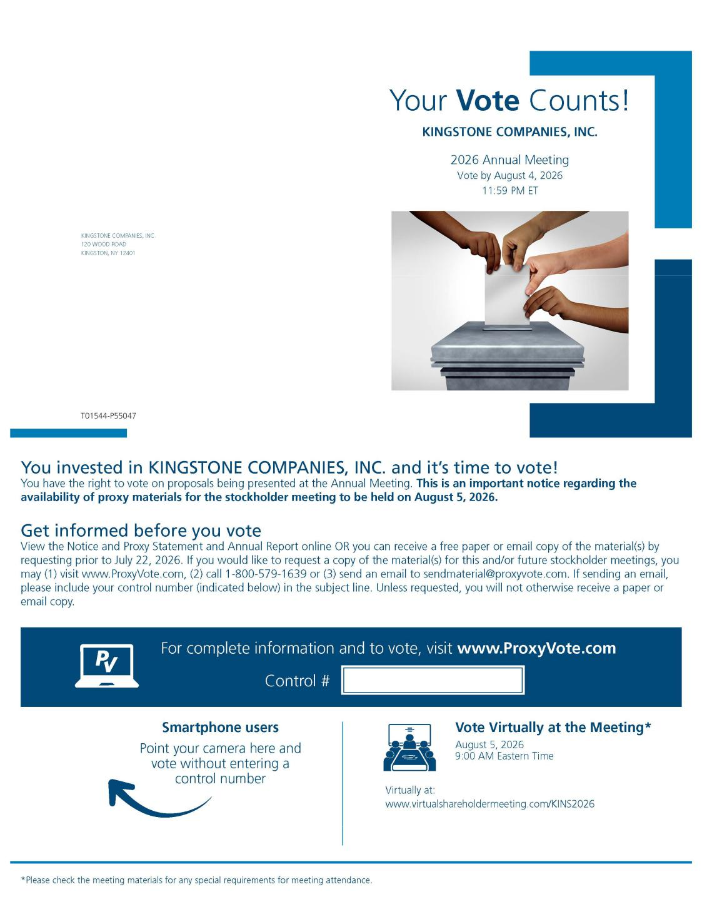

35

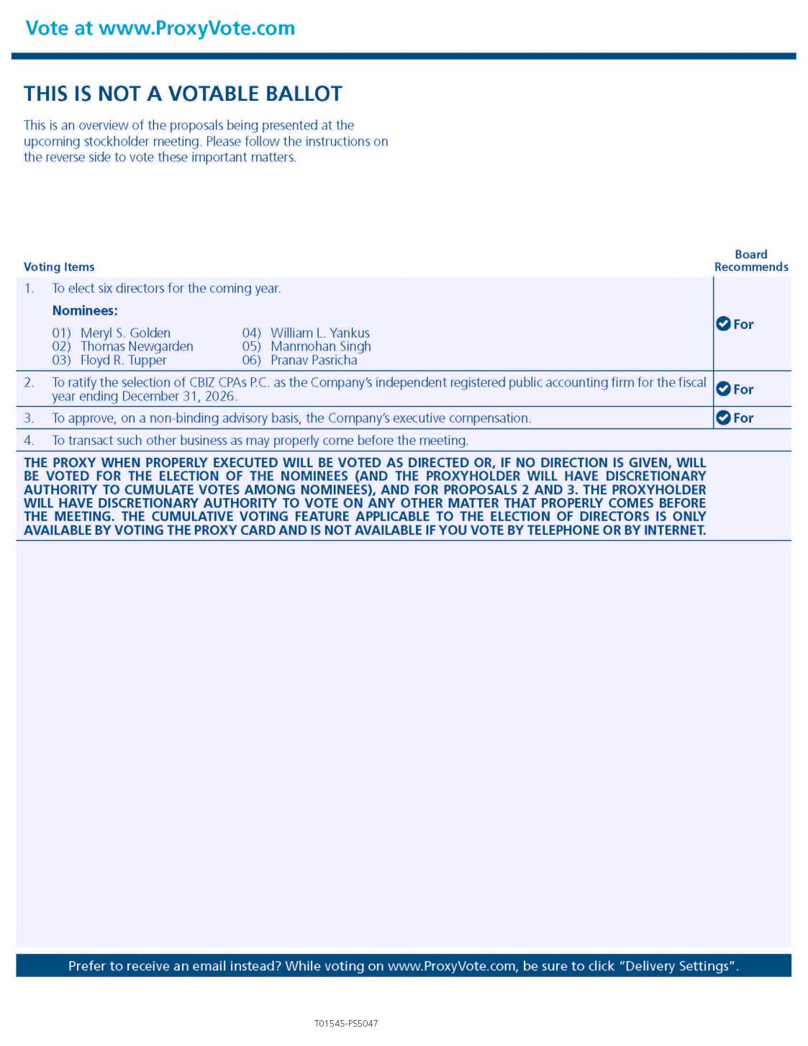

36

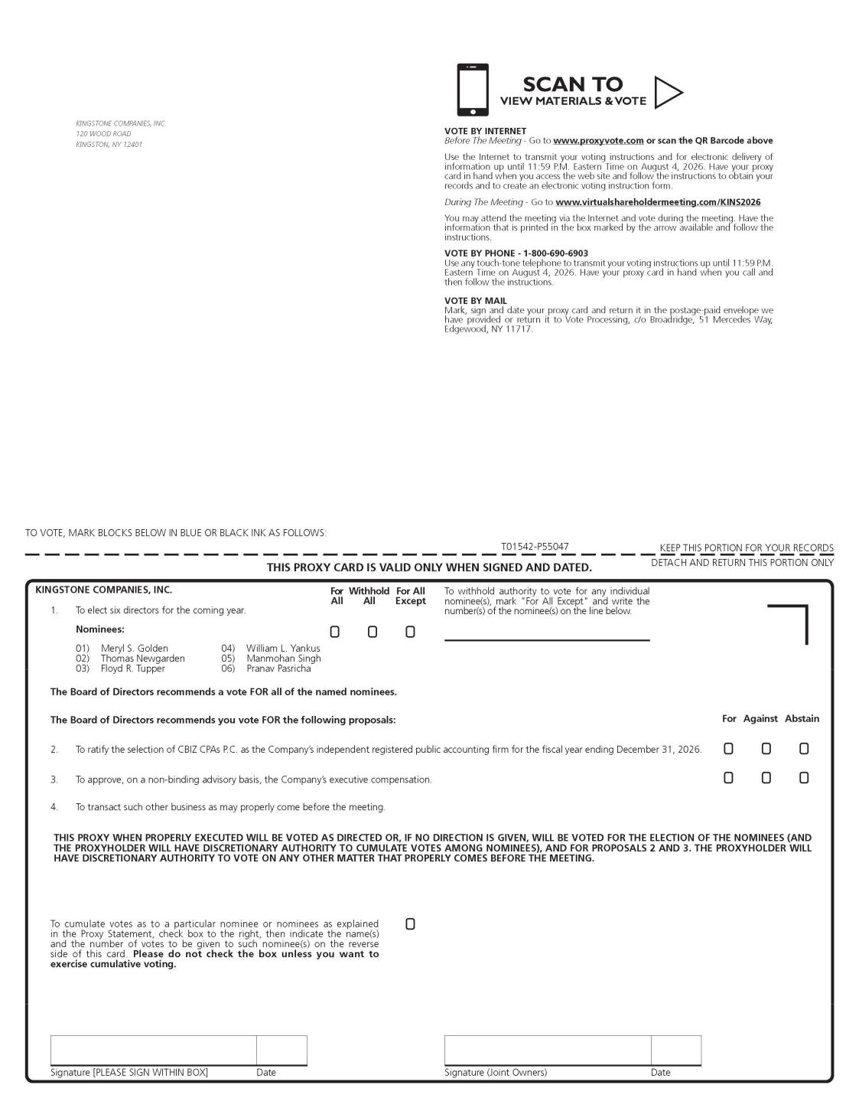

37

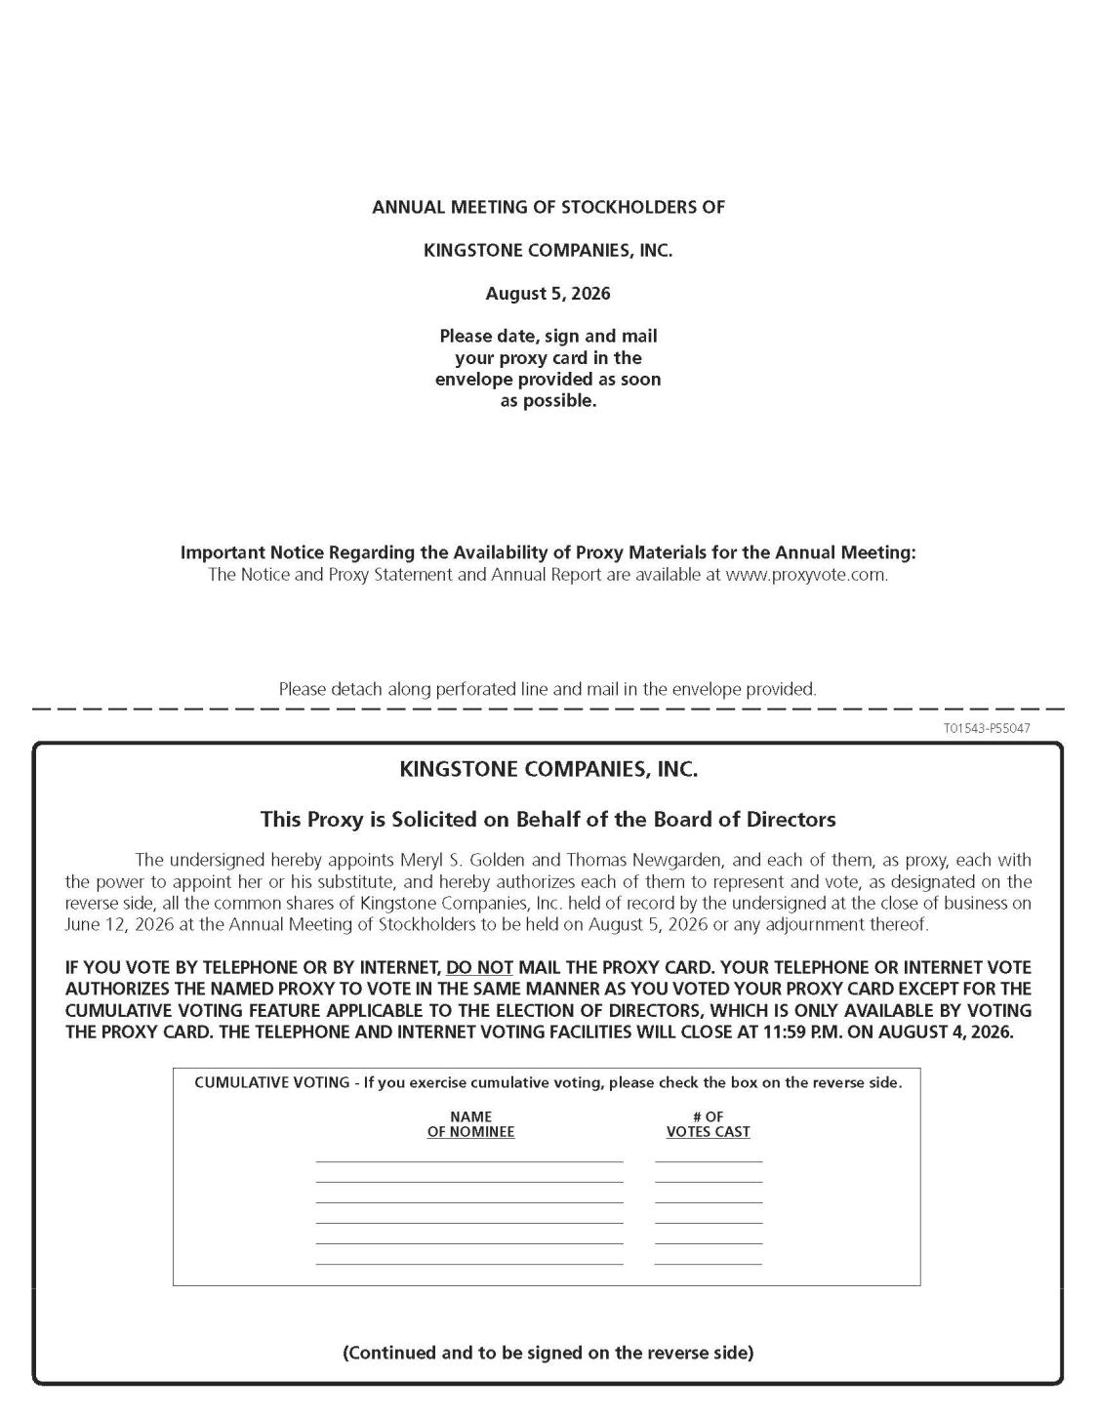

38

